Azure Web Application Firewall (WAF)
Security Testing & Analysis Lab Report

Submitted by: Prakriti Dhungel
University of North Texas
CSCE 5214 / CSCE 4560 / 5560
April 2026

1. Executive Summary
This report documents the complete setup, configuration, and security testing of an Azure Web Application Firewall (WAF) deployed via Azure Application Gateway. The primary objective was to understand how a cloud-native WAF detects and blocks common OWASP Top 10 web attacks including Cross-Site Scripting (XSS), SQL Injection, Path Traversal, and automated scanner reconnaissance.

The WAF was configured in Prevention mode using the OWASP Core Rule Set (CRS) 3.2, comprising 187 managed rules. Attack simulations were conducted using two methods: curl commands from a local macOS terminal, and curl commands executed directly inside Azure Cloud Shell. Both testing environments confirmed the WAF's effectiveness. Real WAF firewall logs were successfully retrieved from Azure Log Analytics (AGWFirewallLogs table), showing specific OWASP rule IDs triggered by each attack type, including Rule 941150 (XSS Filter), Rule 941160 (NoScript XSS), Rule 930120 (OS File Access), and Rule 949110 (Anomaly Score Exceeded).

2. Infrastructure Configuration

2.1 Azure Resource Group Overview
All resources were deployed under the resource group prakriti-waf-demo_group in the Central US region, as shown below:

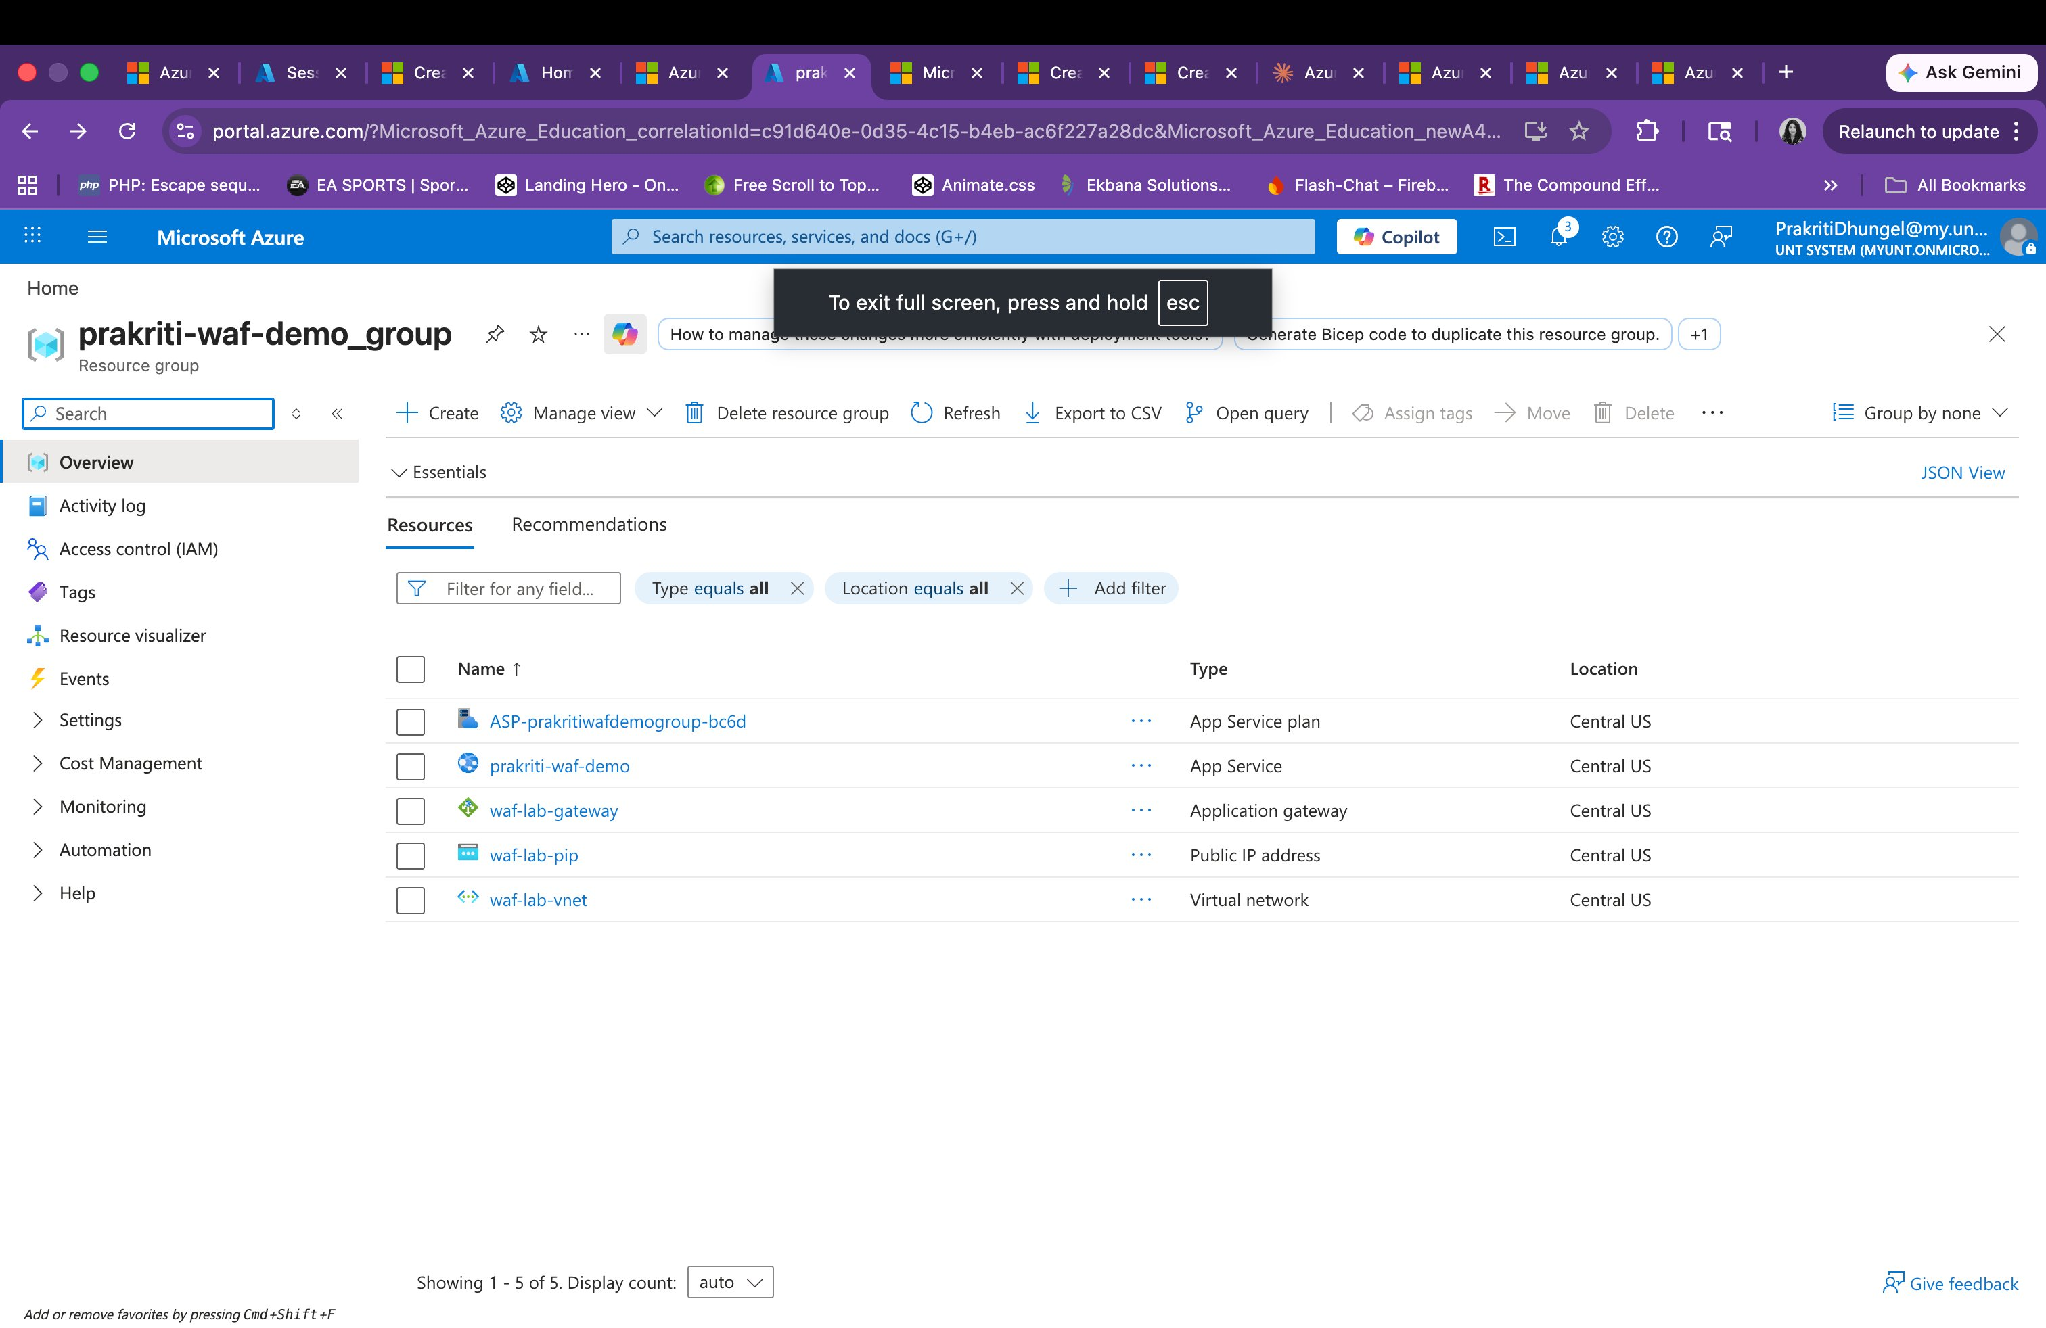
Figure 1: Azure Resource Group showing all 5 deployed resources — App Service, Application Gateway, Public IP, App Service Plan, and Virtual Network

2.2 Azure Web Application
A Python 3.11 web application was deployed on Azure App Service as the WAF backend target. The app was confirmed running with a publicly accessible URL.

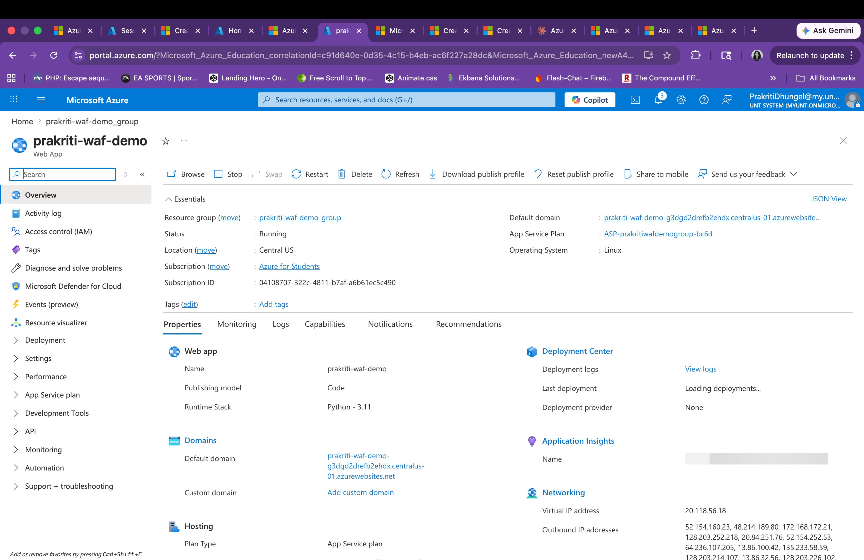
Figure 2: Azure App Service (prakriti-waf-demo) showing Running status and public domain URL

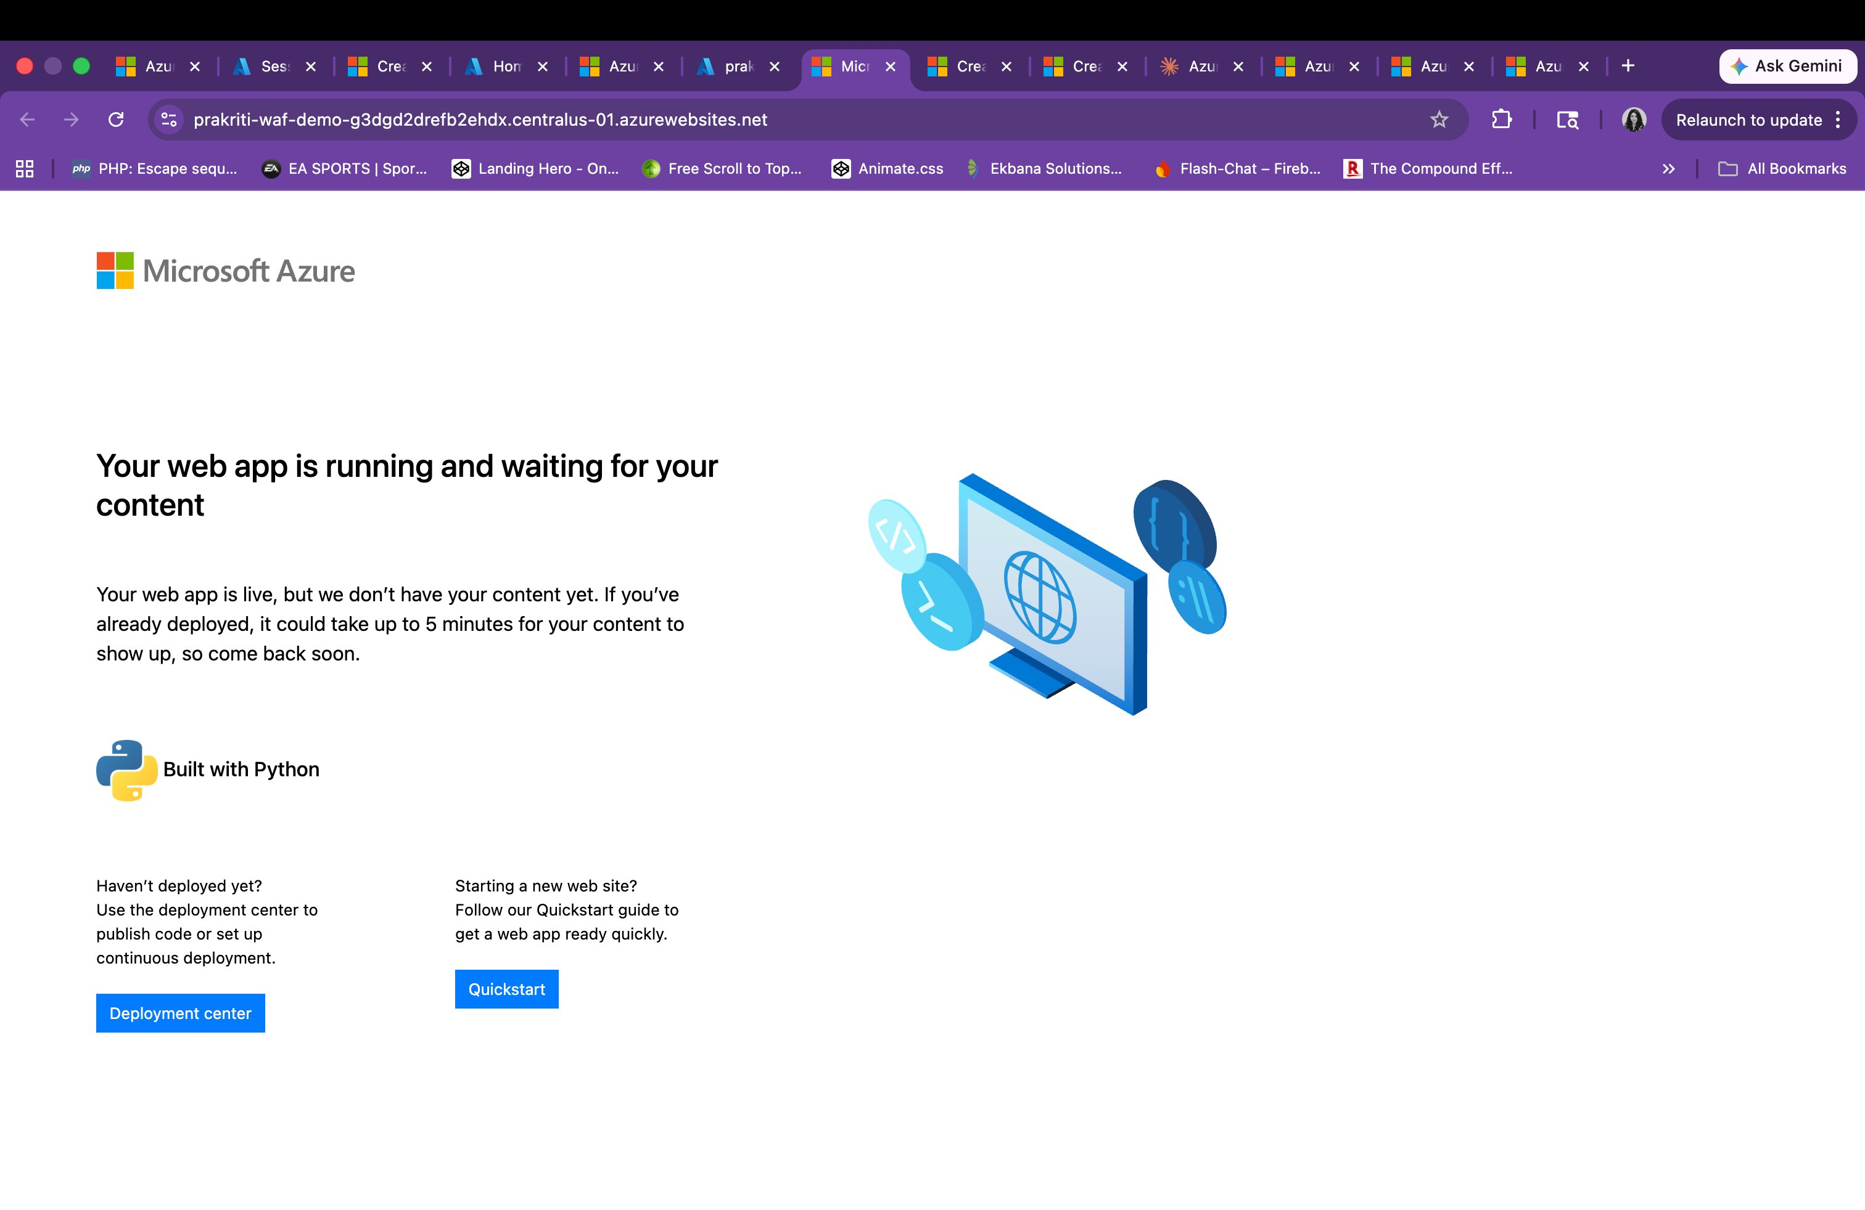
Figure 3: Web application live and accessible at the Azure default domain — confirming successful deployment

Parameter | Value
Resource Name | prakriti-waf-demo
Resource Group | prakriti-waf-demo_group
Runtime Stack | Python 3.11 / Linux
Region | Central US
Status | Running
Public URL | prakriti-waf-demo-g3dgd2drefb2ehdx.centralus-01.azurewebsites.net

2.3 Azure Application Gateway
An Azure Application Gateway was provisioned as the single secure entry point for all incoming traffic. All requests are inspected by the WAF before being forwarded to the backend App Service.

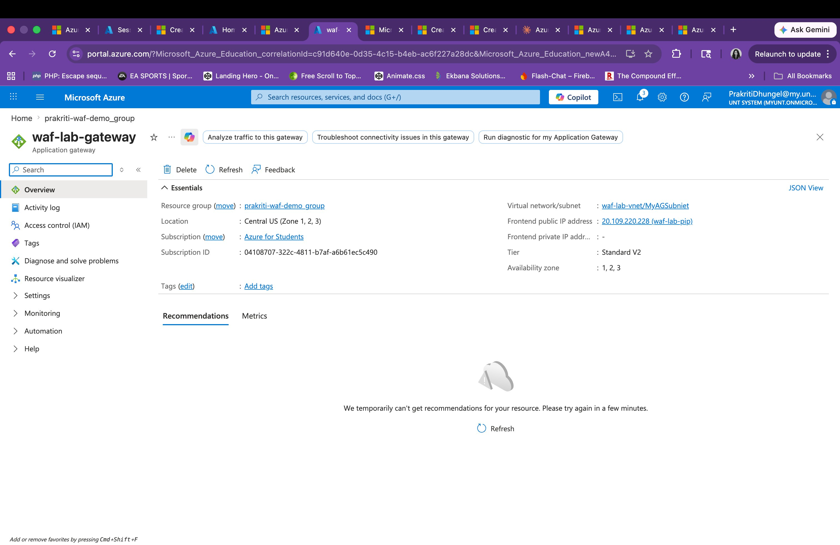
Figure 4: Application Gateway (waf-lab-gateway) overview showing Frontend Public IP 20.109.220.228 and WAF V2 tier

Parameter | Value
Gateway Name | waf-lab-gateway
Frontend Public IP | 20.109.220.228 (waf-lab-pip)
Virtual Network / Subnet | waf-lab-vnet / MyAGSubnet
Tier | Standard V2 with WAF Policy
Backend Pool | prakriti-waf-demo (App Service)
Listener | http-listener on Port 80 (HTTP)
Routing Rule | http-rule (Priority 100)
Location | Central US (Availability Zones 1, 2, 3)

3. WAF Policy Configuration

3.1 Prevention Mode
The WAF policy (waf-lab-policy) was initially set to Detection mode and then switched to Prevention mode. In Prevention mode, the WAF actively blocks all requests that match attack signatures with an HTTP 403 Forbidden response, rather than merely logging them.

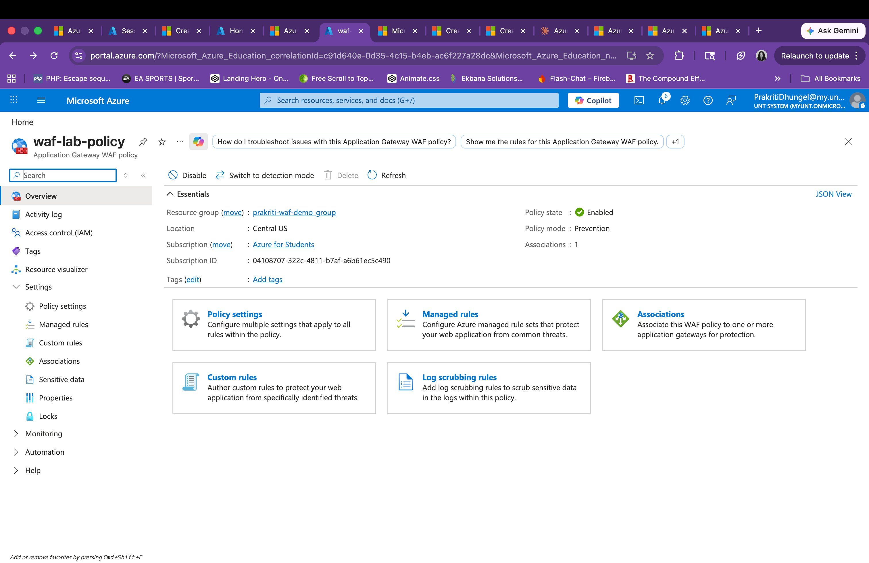
Figure 5: WAF Policy (waf-lab-policy) showing Policy mode: Prevention and Policy state: Enabled with 1 association to the Application Gateway

3.2 OWASP 3.2 Managed Rules
The OWASP Core Rule Set 3.2 was applied, providing 187 managed rules across multiple rule groups covering the full OWASP Top 10. Key rule groups active in this configuration include: 941xxx (XSS Filter Rules), 942xxx (SQL Injection Detection), 913xxx (Scanner Detection), 930xxx (Local File Inclusion / Path Traversal), and 949xxx (Anomaly Scoring).

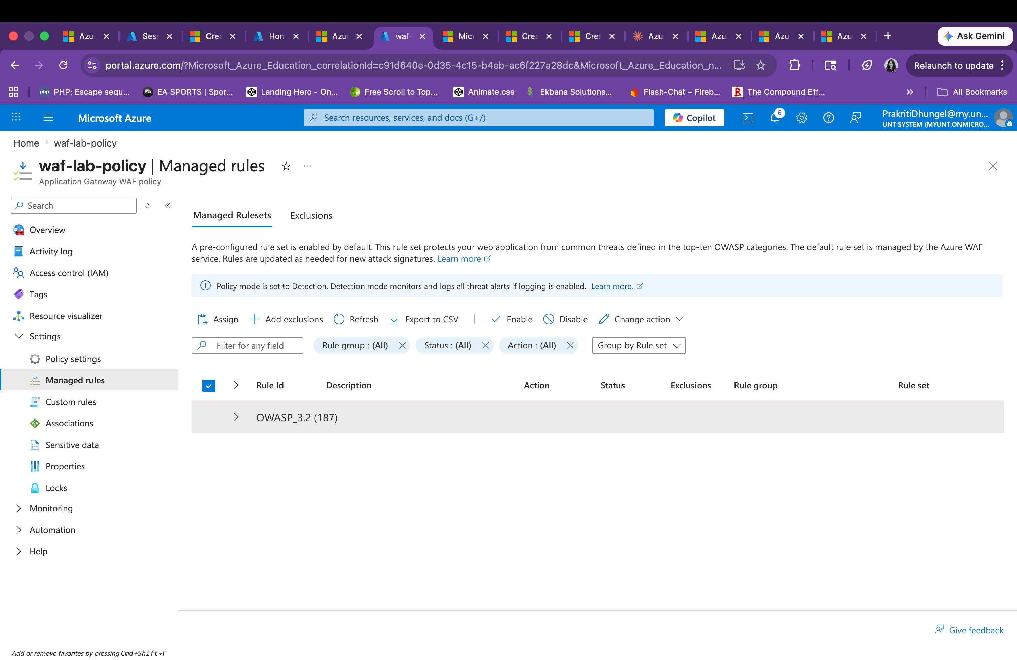
Figure 6: Managed Rules page showing OWASP_3.2 rule set with 187 active managed rules

3.3 Diagnostic Settings
Diagnostic settings were configured on the Application Gateway to stream WAF Firewall Logs and Access Logs to the waf-log-workspace Log Analytics workspace, enabling real-time monitoring and post-incident forensic analysis.

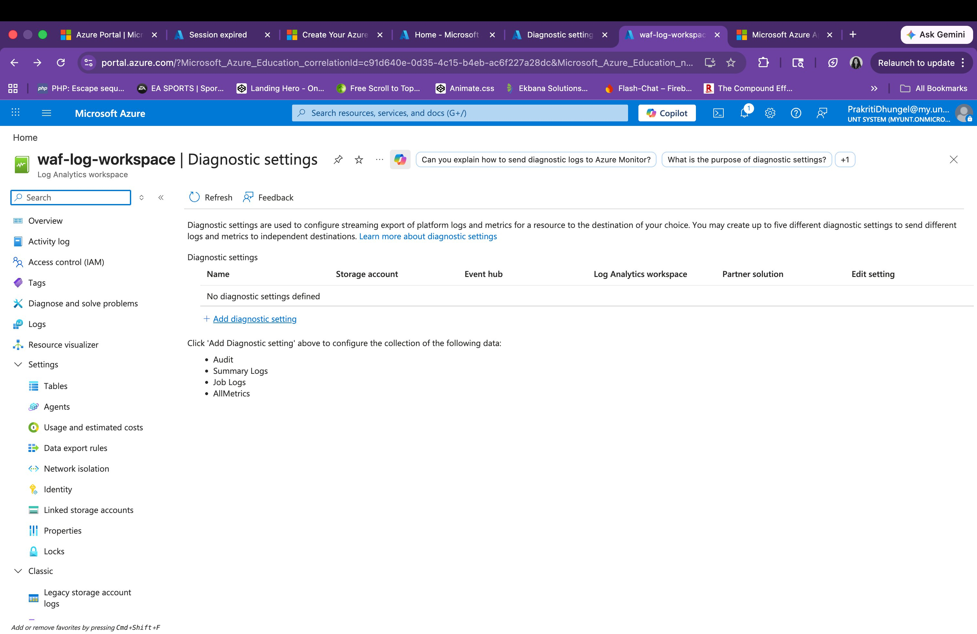
Figure 7: Diagnostic setting (waf-daignostics) showing Application Gateway Firewall Log and Access Log streaming to waf-log-workspace (Central US)

Parameter | Value
Diagnostic Setting Name | waf-daignostics
Log Analytics Workspace | waf-log-workspace (Central US)
Logs Captured | Application Gateway Access Log, Application Gateway Firewall Log
Destination | Send to Log Analytics workspace — Resource specific table

4. Security Testing

4.1 Testing Methodology
Security testing was performed using two different environments to ensure comprehensive coverage and validate WAF behavior from both external and cloud-internal network perspectives:

- macOS Terminal (curl v8.7.1): Attack payloads were sent from a local machine to the Application Gateway public IP (20.109.220.228), simulating an external attacker.
- Azure Cloud Shell (curl v8.11.1): The same attack payloads were sent from within Azure Cloud Shell, simulating attacks from a cloud-internal or lateral movement scenario.

Both testing environments produced consistent results — HTTP 403 Forbidden responses for blocked attacks — confirming the WAF enforcement is applied at the Application Gateway level regardless of the request origin.

4.2 Azure Cloud Shell Test Execution
The following screenshots show the attack commands run from Azure Cloud Shell and the resulting 403 responses, confirming WAF blocking behavior from a cloud-internal network context:

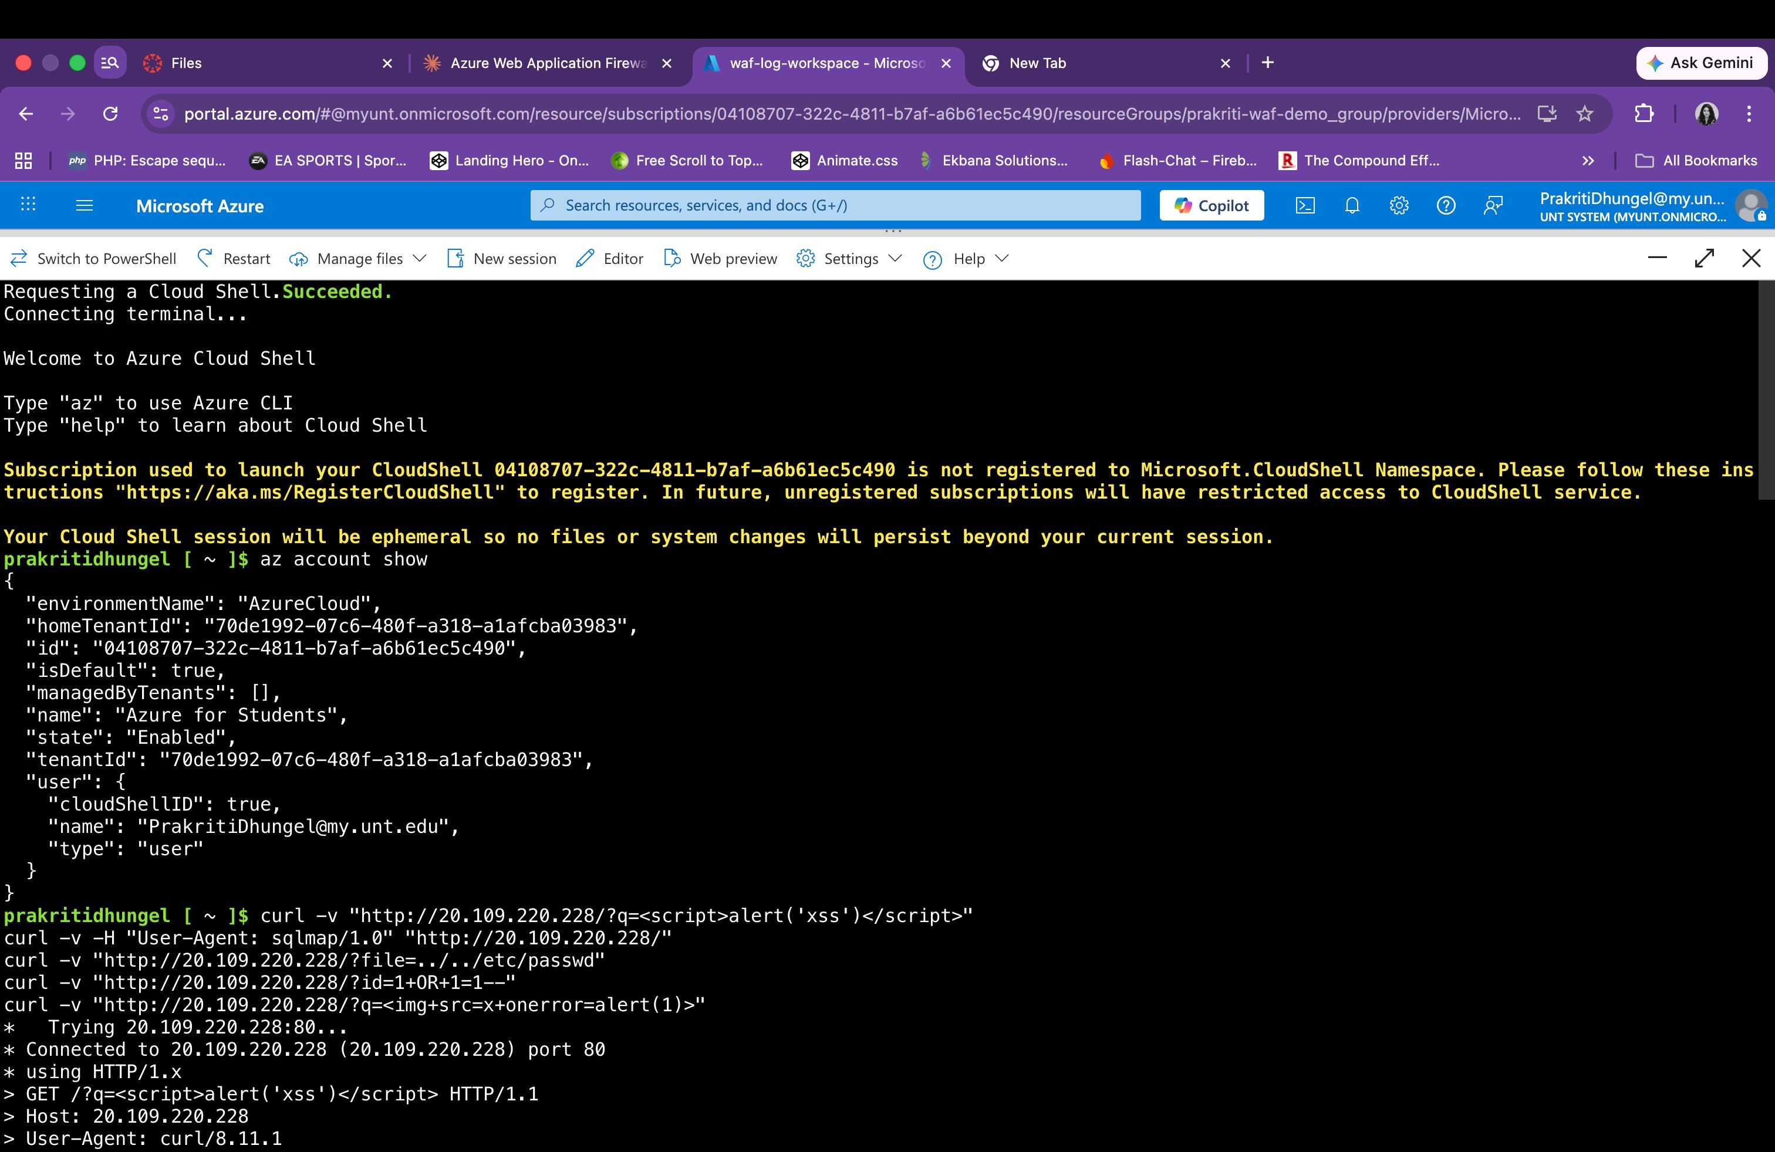
Figure 8: Azure Cloud Shell showing attack commands being submitted — XSS, SQLmap scanner, path traversal, SQL injection, and img-based XSS payloads

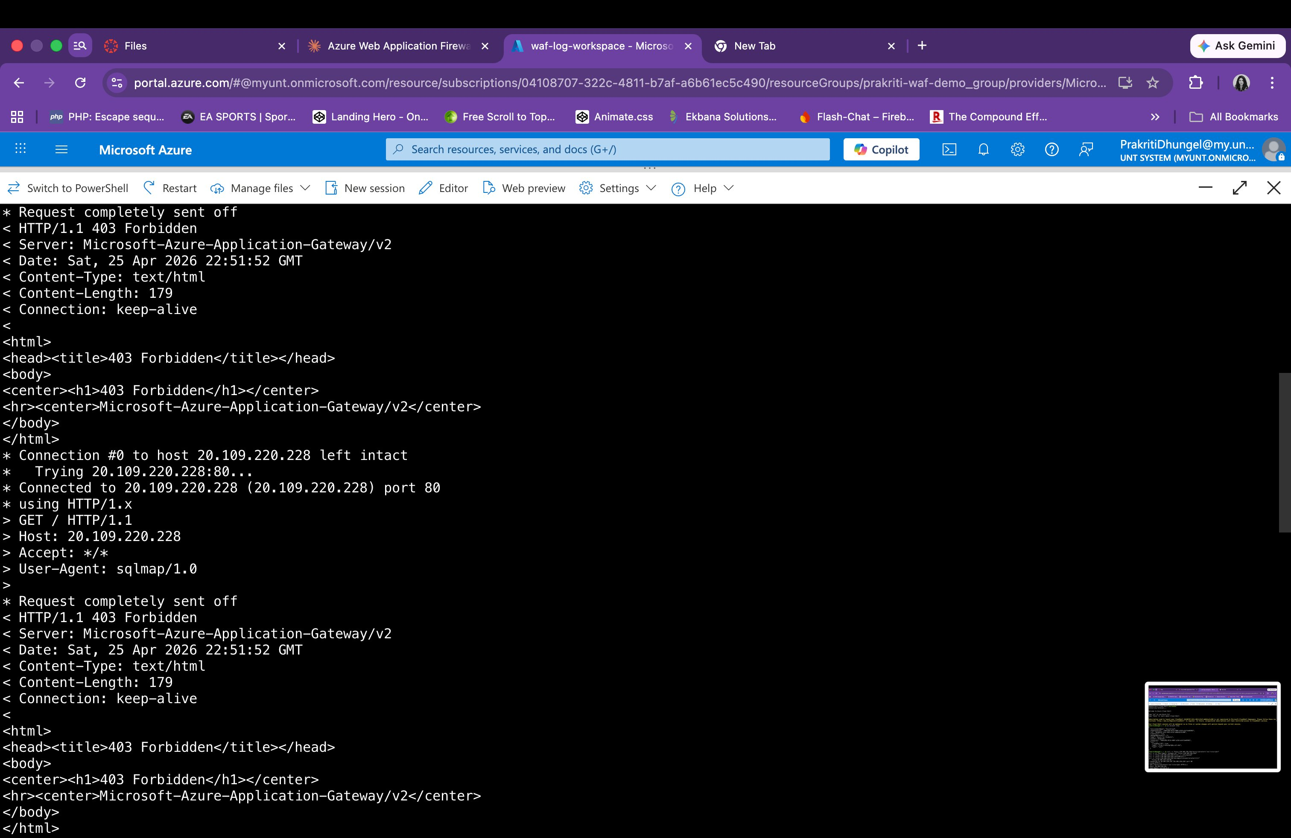
Figure 9: Cloud Shell results — XSS payload blocked with HTTP 403 Forbidden (Sat, 25 Apr 2026 22:51:52 GMT) and SQLmap User-Agent blocked with HTTP 403 Forbidden

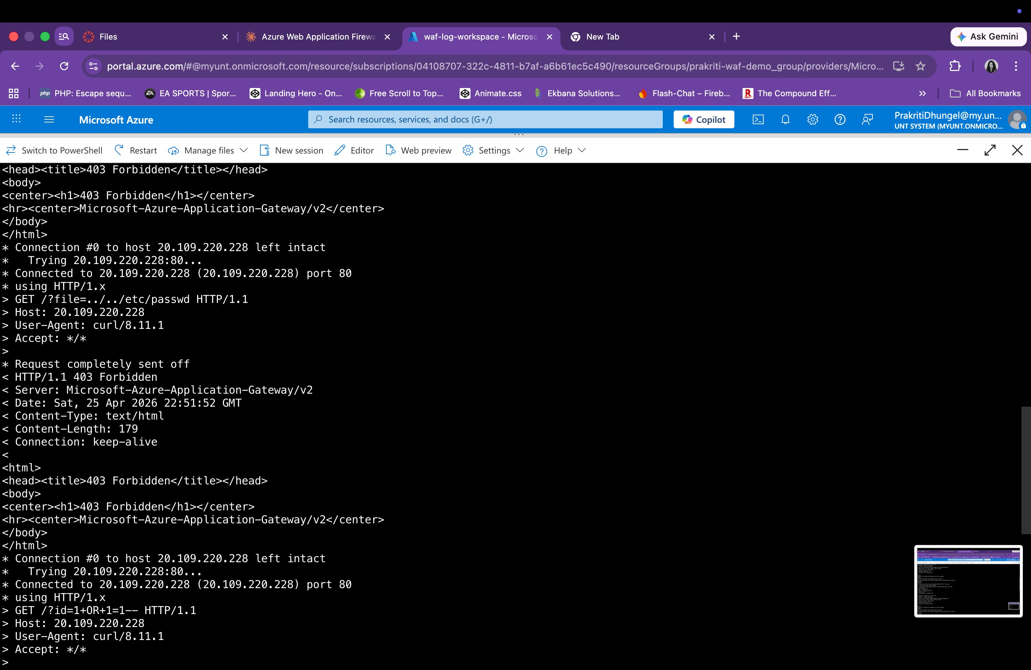
Figure 10: Cloud Shell results — Path traversal (?file=../../etc/passwd) blocked with HTTP 403 Forbidden, and SQL injection (?id=1+OR+1=1--) blocked with HTTP 403 Forbidden

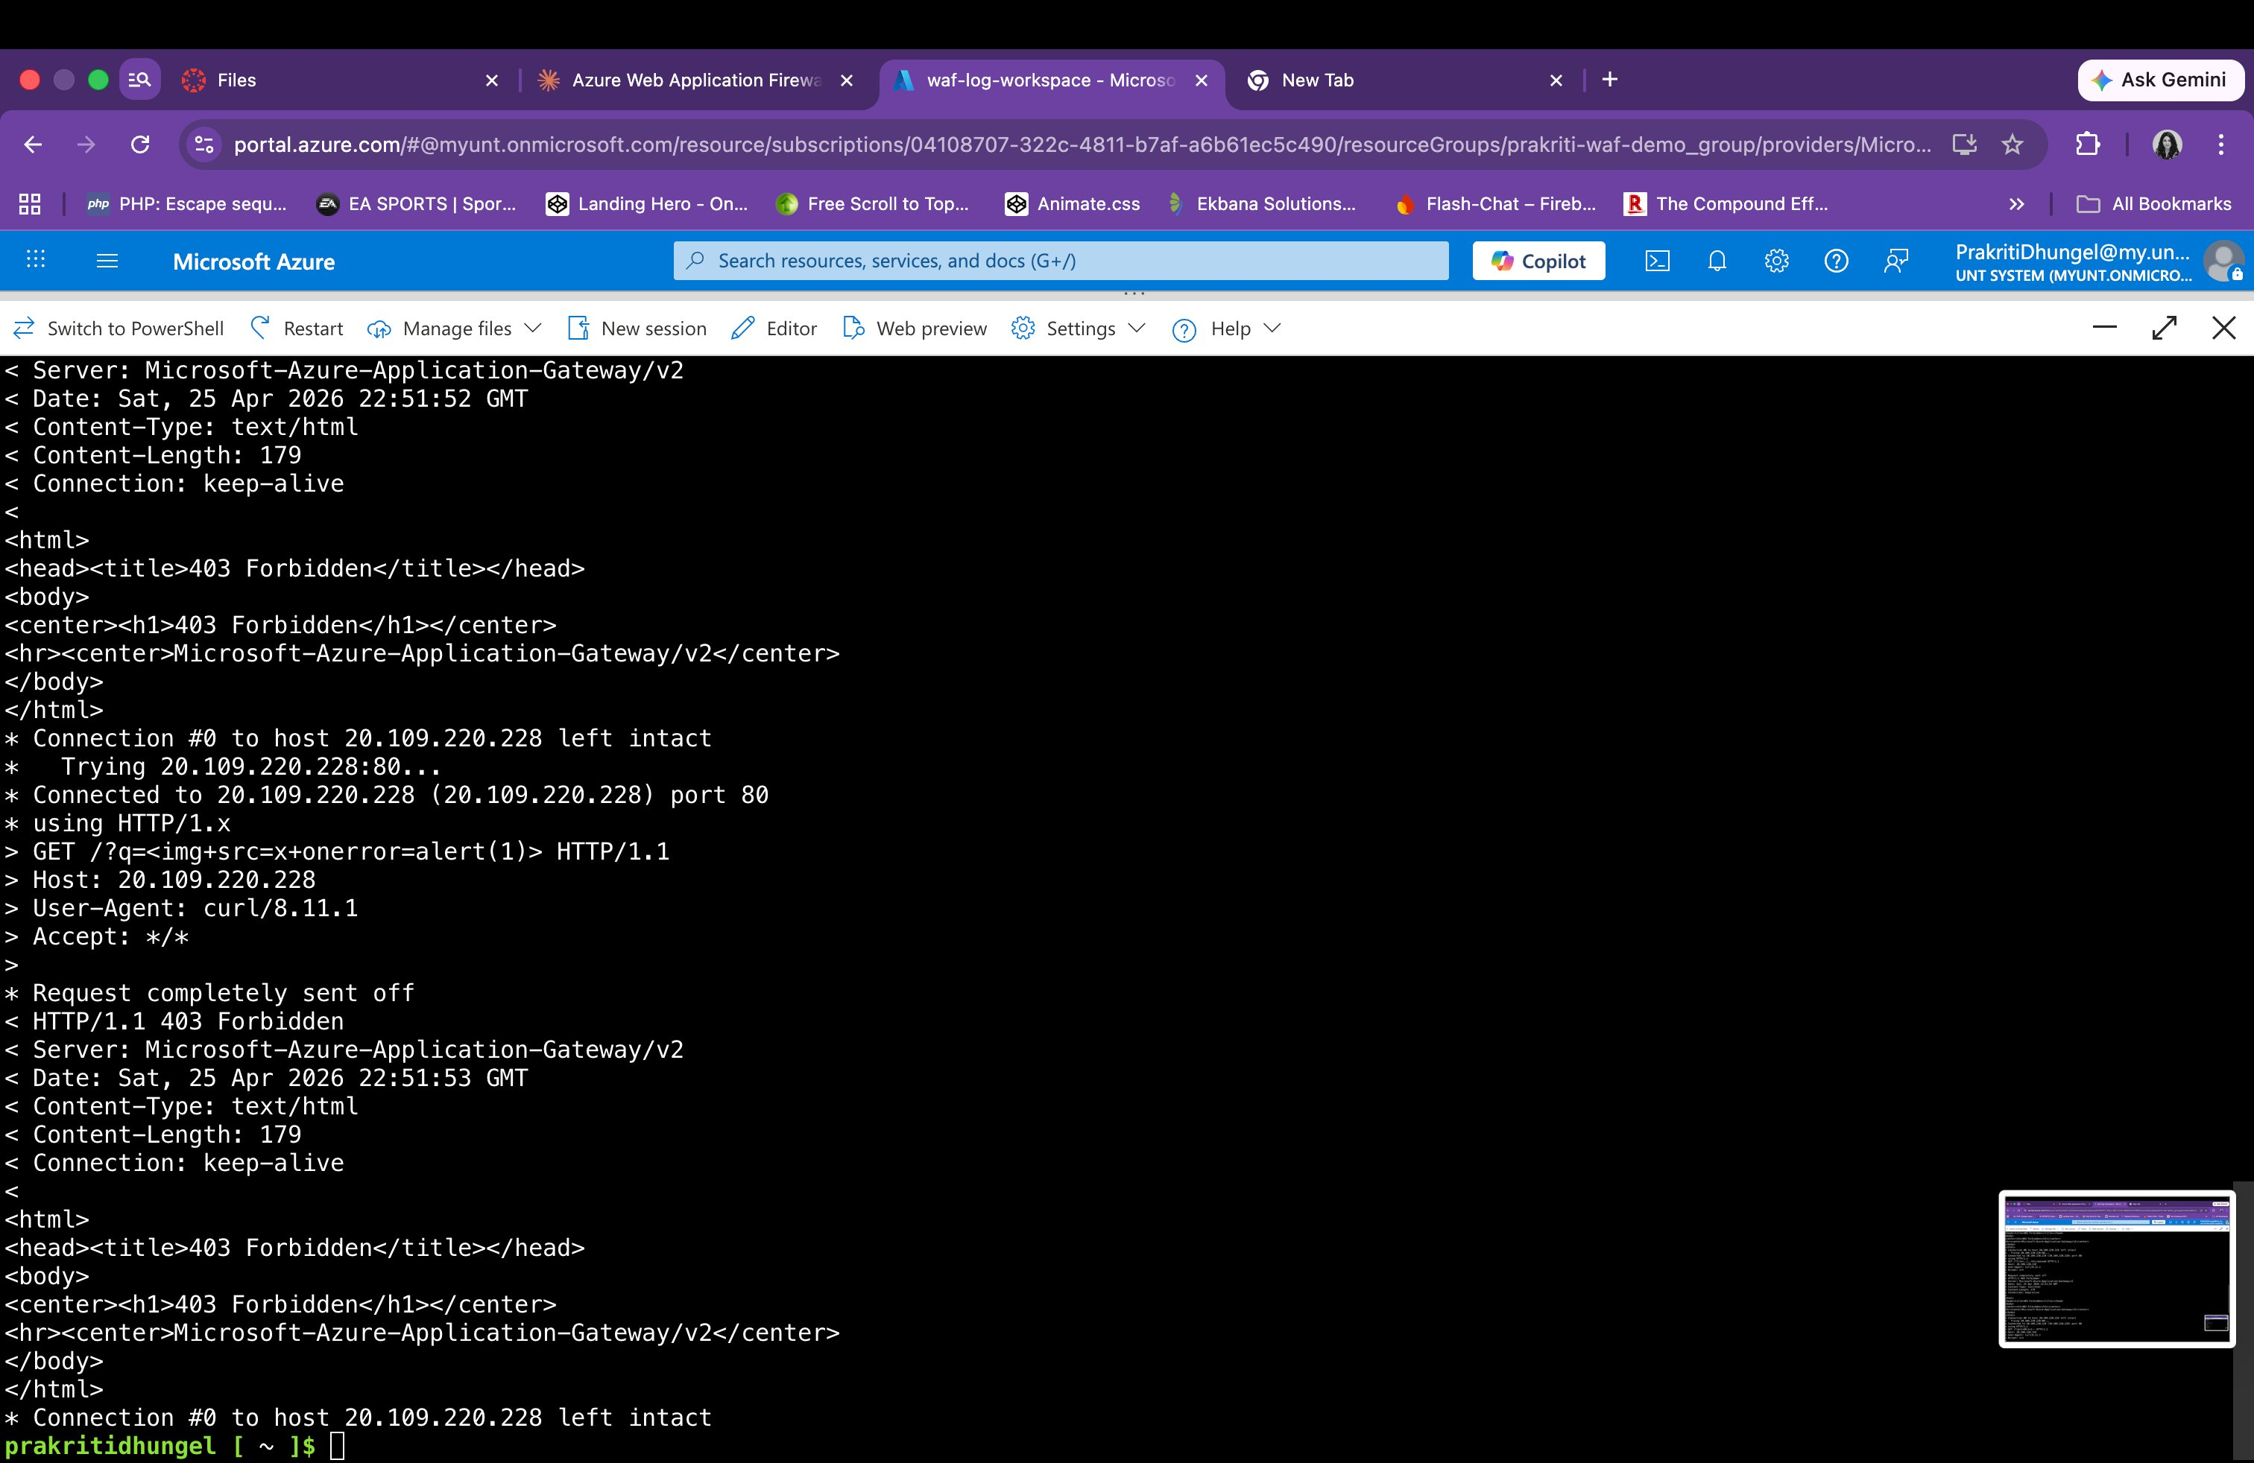
Figure 11: Cloud Shell results — Image-based XSS payload (?q=<img+src=x+onerror=alert(1)>) blocked with HTTP 403 Forbidden — all 5 attack types confirmed blocked

4.3 Local Terminal Test Results (macOS)
The following screenshots show the original test round conducted from the local macOS terminal, confirming WAF behavior from an external network perspective:

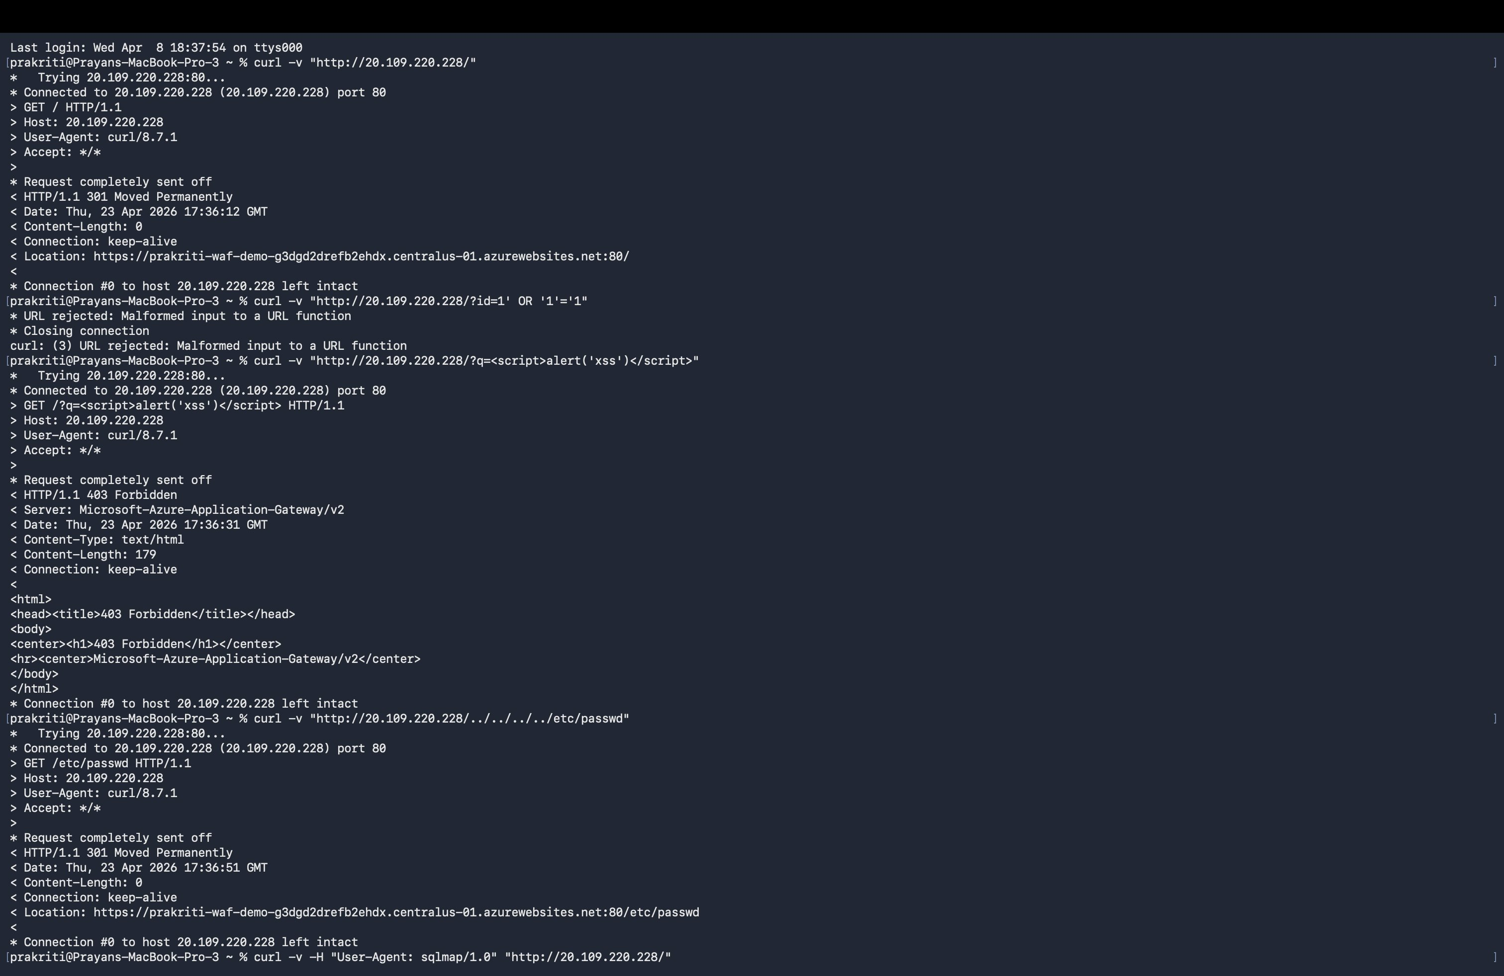
Figure 12: macOS terminal — XSS payload blocked with HTTP 403 Forbidden by Microsoft-Azure-Application-Gateway/v2

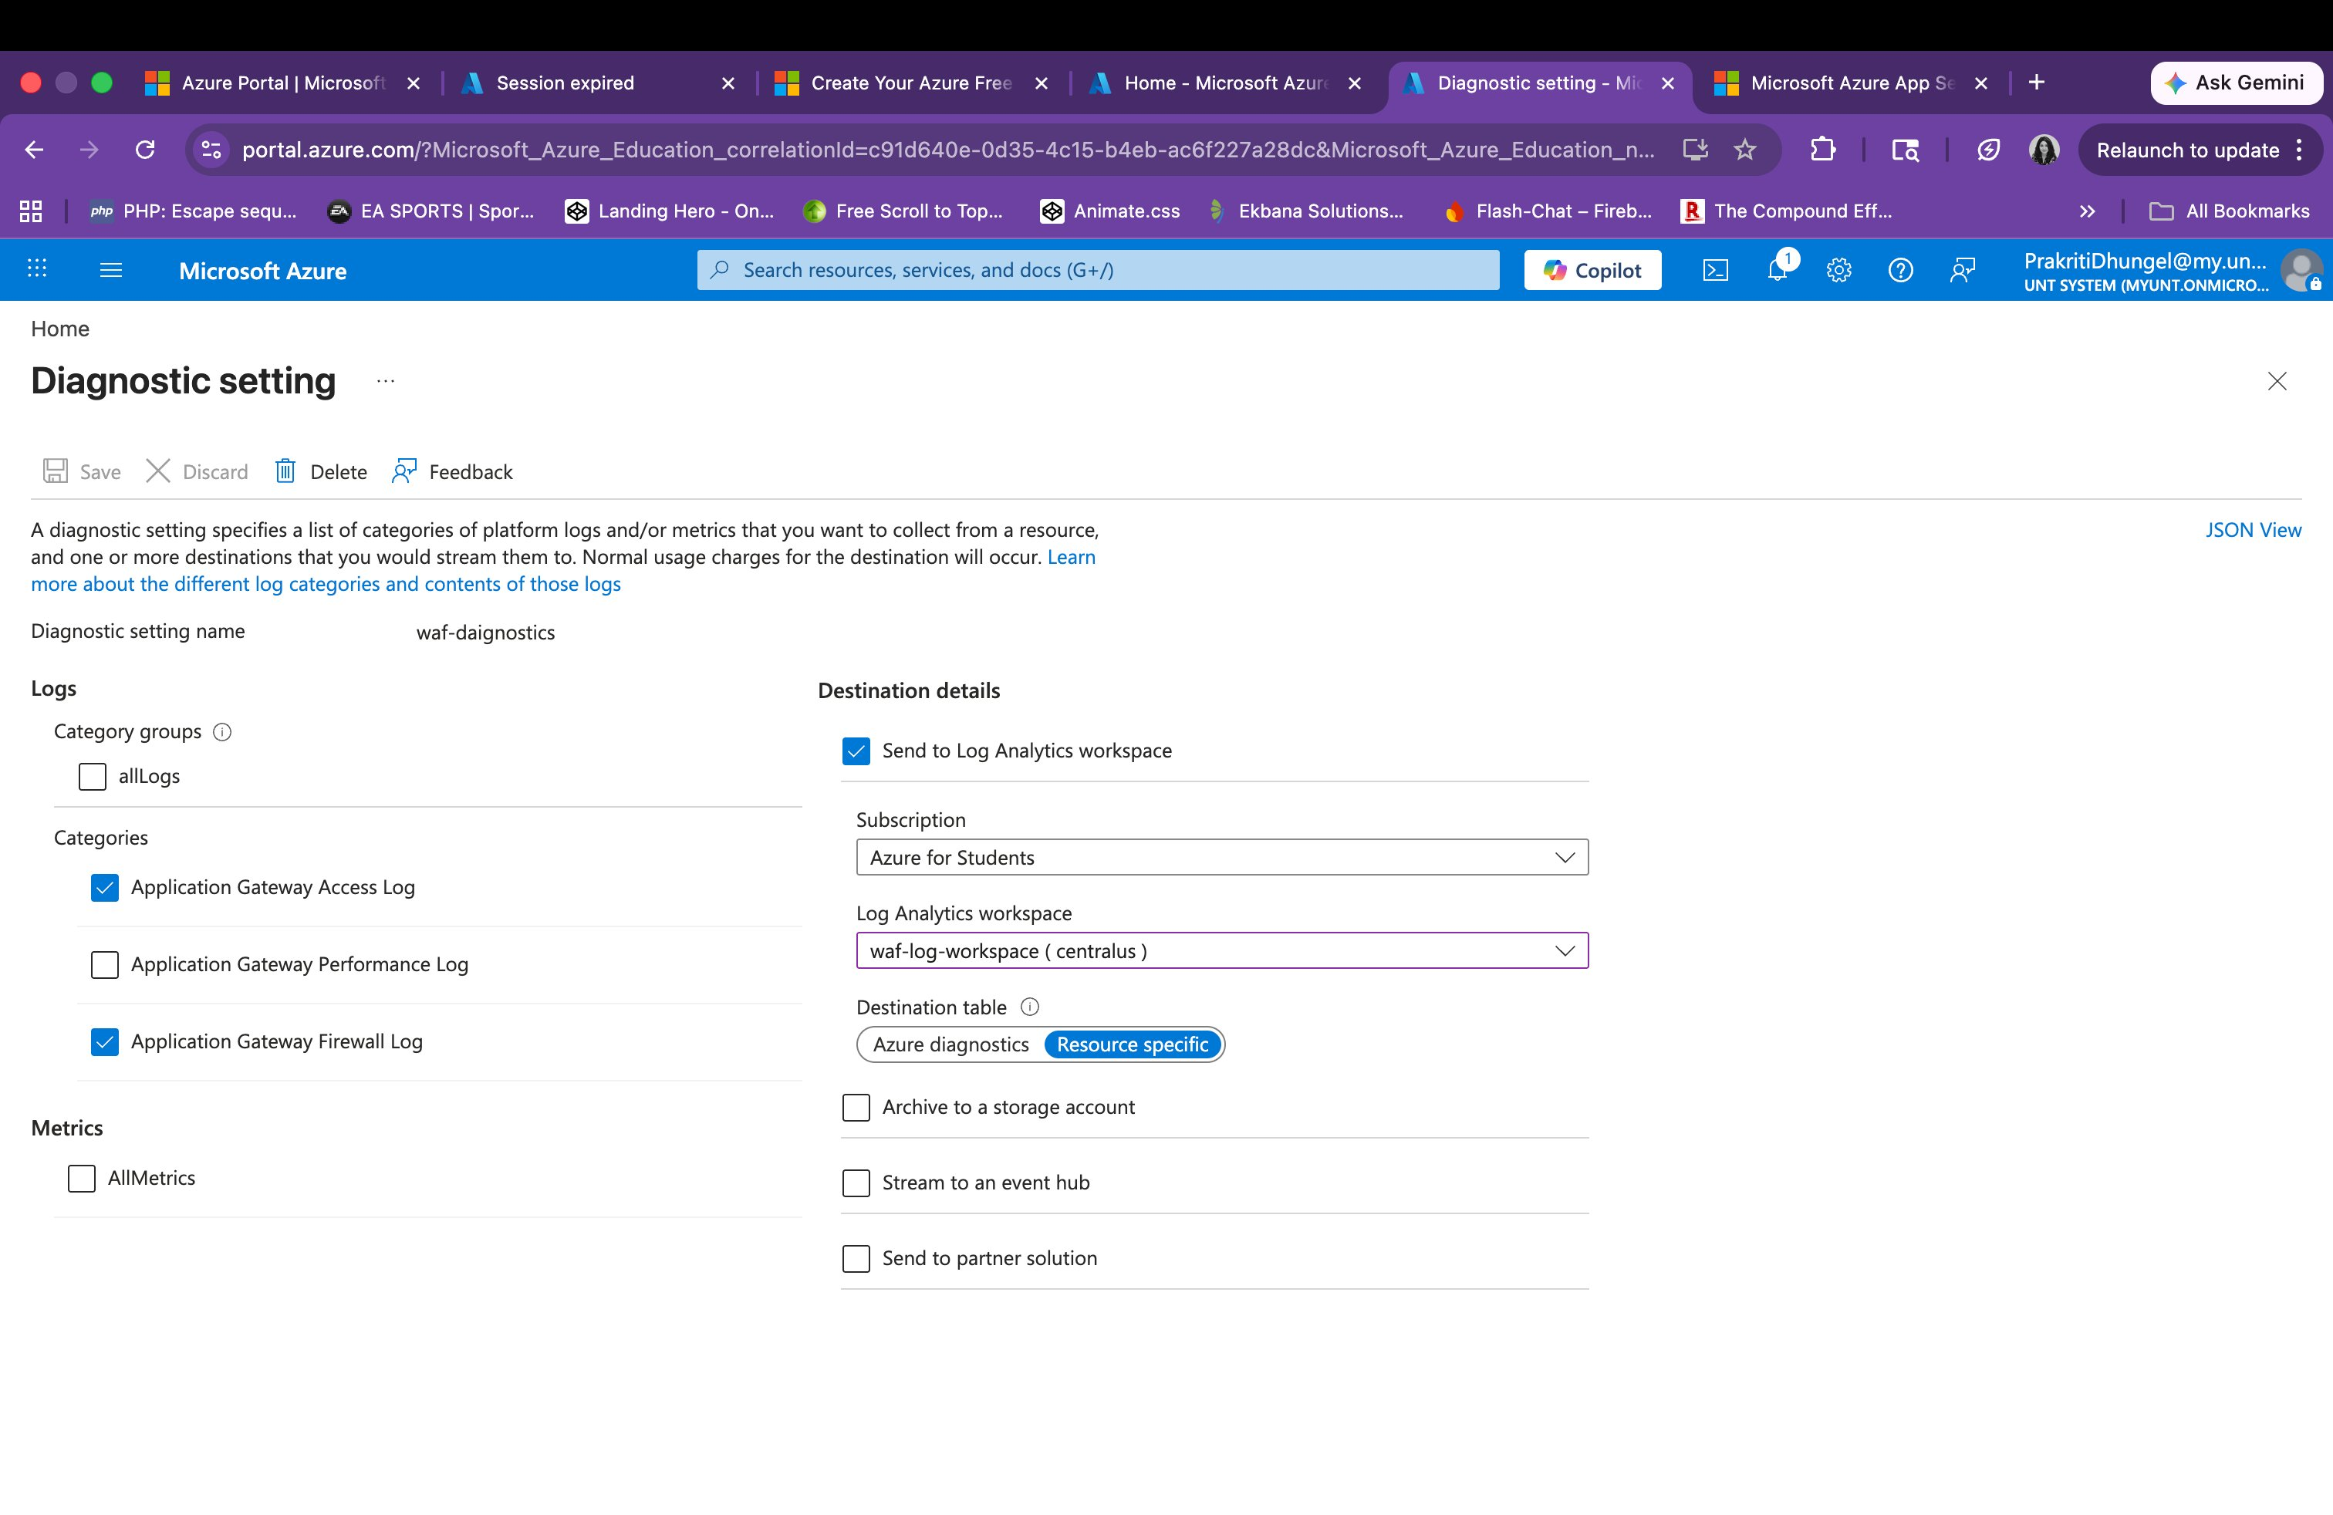
Figure 13: macOS terminal — Path traversal (301 redirect) and SQLmap User-Agent (403 Forbidden) results

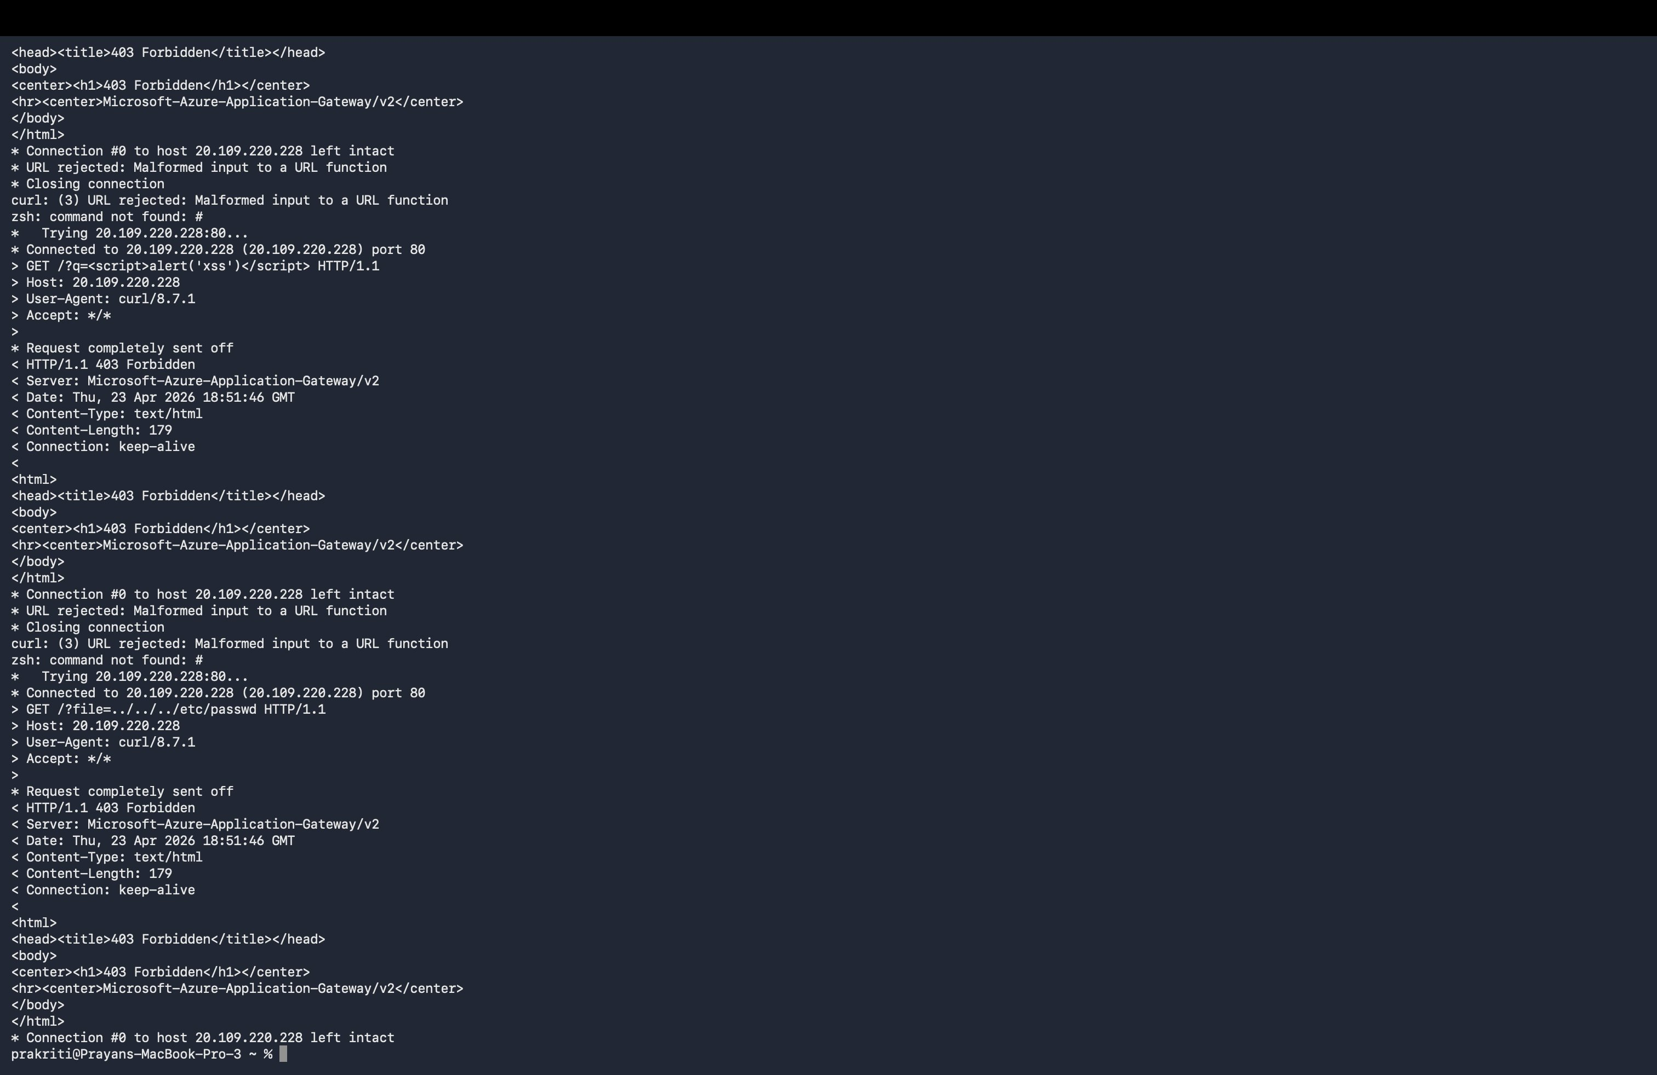
Figure 14: macOS terminal round 2 — XSS and SQLmap attacks consistently blocked with 403

5. WAF Log Analysis

5.1 Log Analytics Query
After running attacks from Azure Cloud Shell, WAF firewall logs were successfully retrieved from the AGWFirewallLogs table in the waf-log-workspace Log Analytics workspace. The following KQL query was used:

AGWFirewallLogs
| order by TimeGenerated desc

Note: Logs are stored in the AGWFirewallLogs resource-specific table (not AzureDiagnostics) because the diagnostic setting was configured with the Resource specific destination table option.

5.2 Log Results — Real WAF Firewall Events
The query returned 1,000 firewall log entries. The screenshots below show expanded log records with the specific OWASP rules triggered by each attack type:

Log Entry 1 — XSS Attack: Rule 941150 (XSS Filter Category 5)
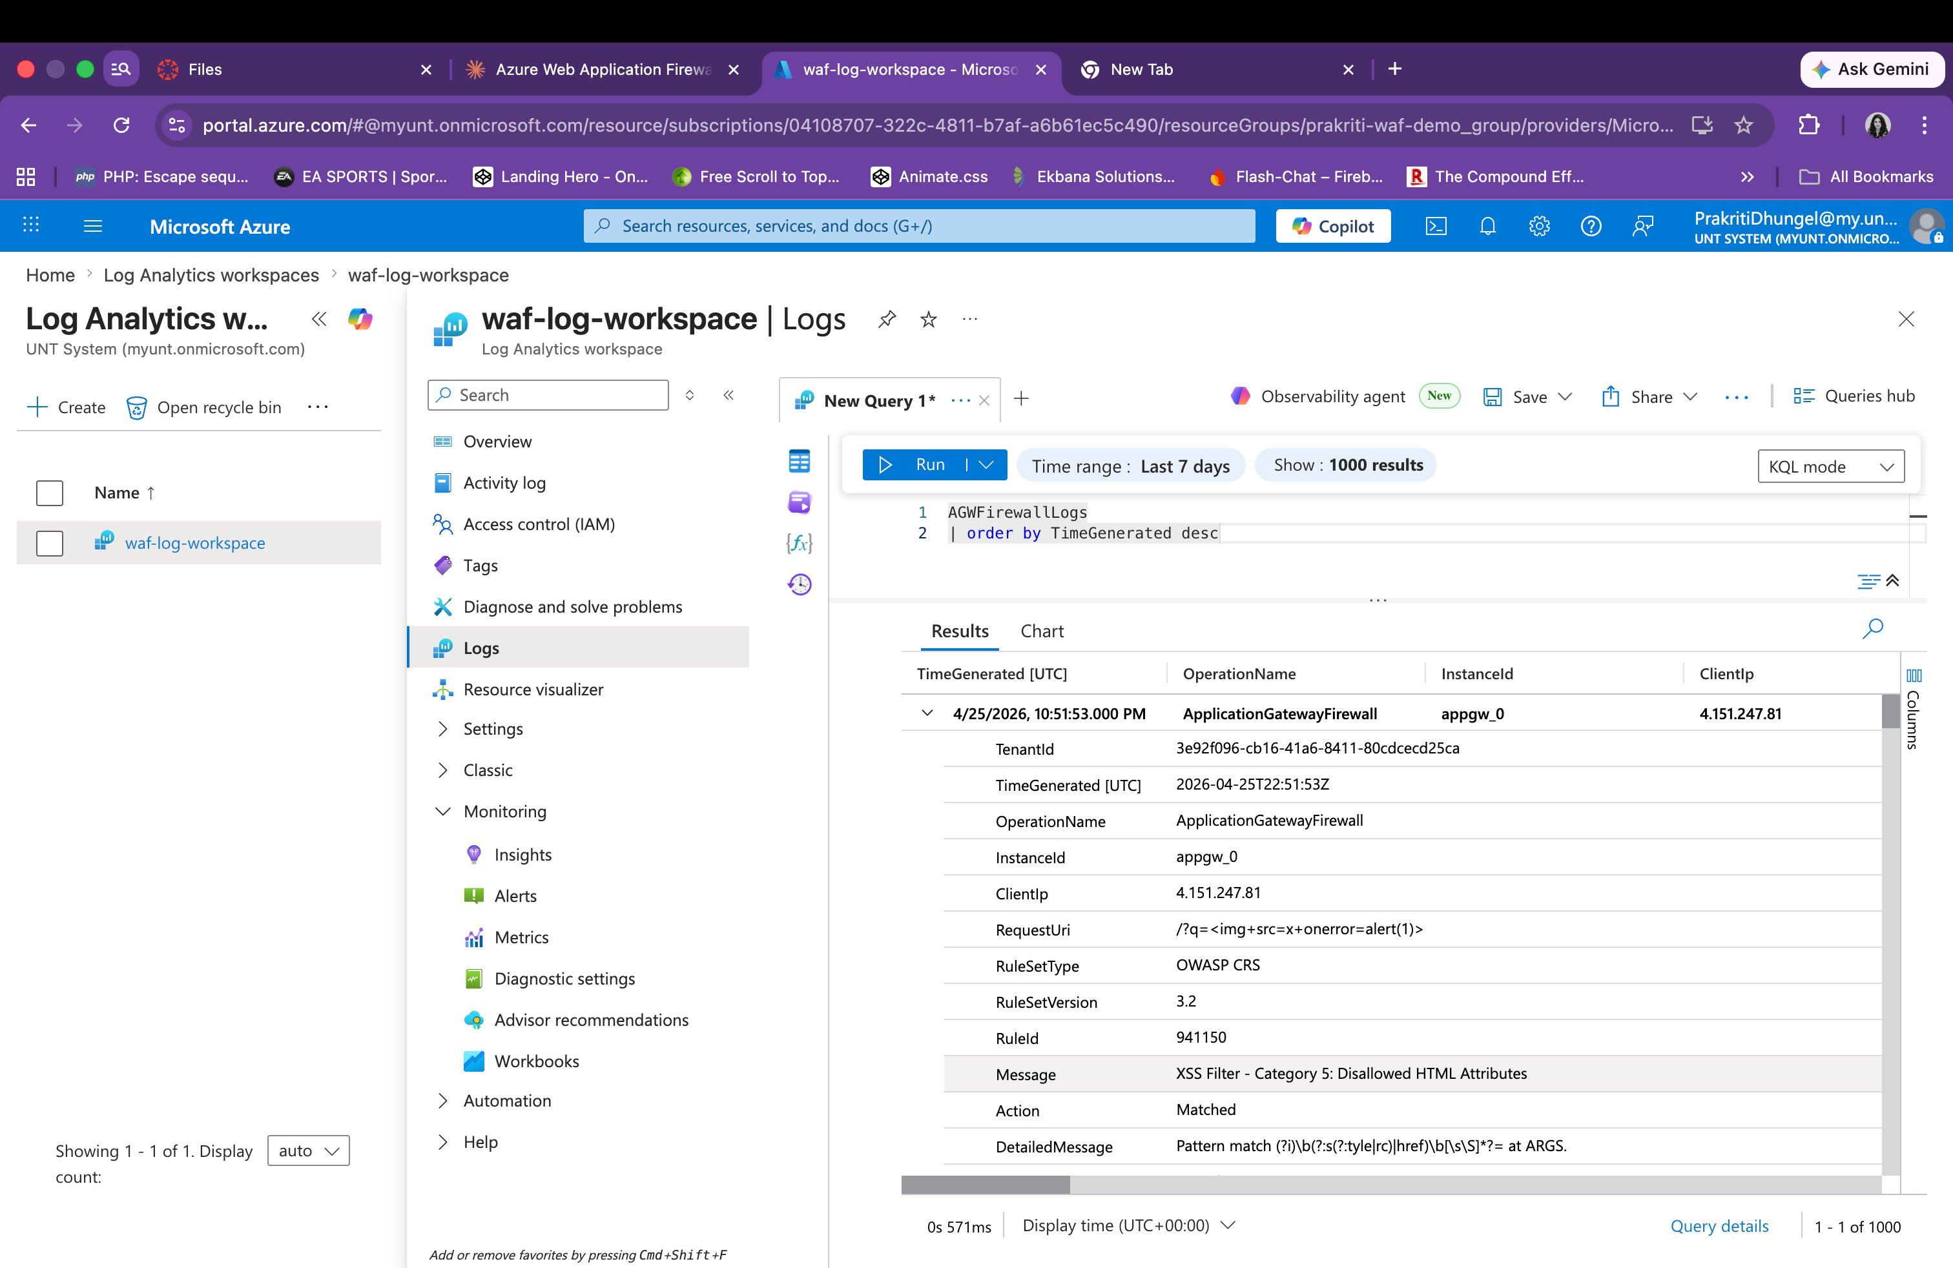
Figure 15: AGWFirewallLogs entry showing RequestUri: /?q=<img+src=x+onerror=alert(1)>, RuleSetType: OWASP CRS, RuleSetVersion: 3.2, RuleId: 941150, Message: XSS Filter - Category 5: Disallowed HTML Attributes, Action: Matched

Log Entry 2 — XSS Attack: Rule 941160 (NoScript XSS InjectionChecker)
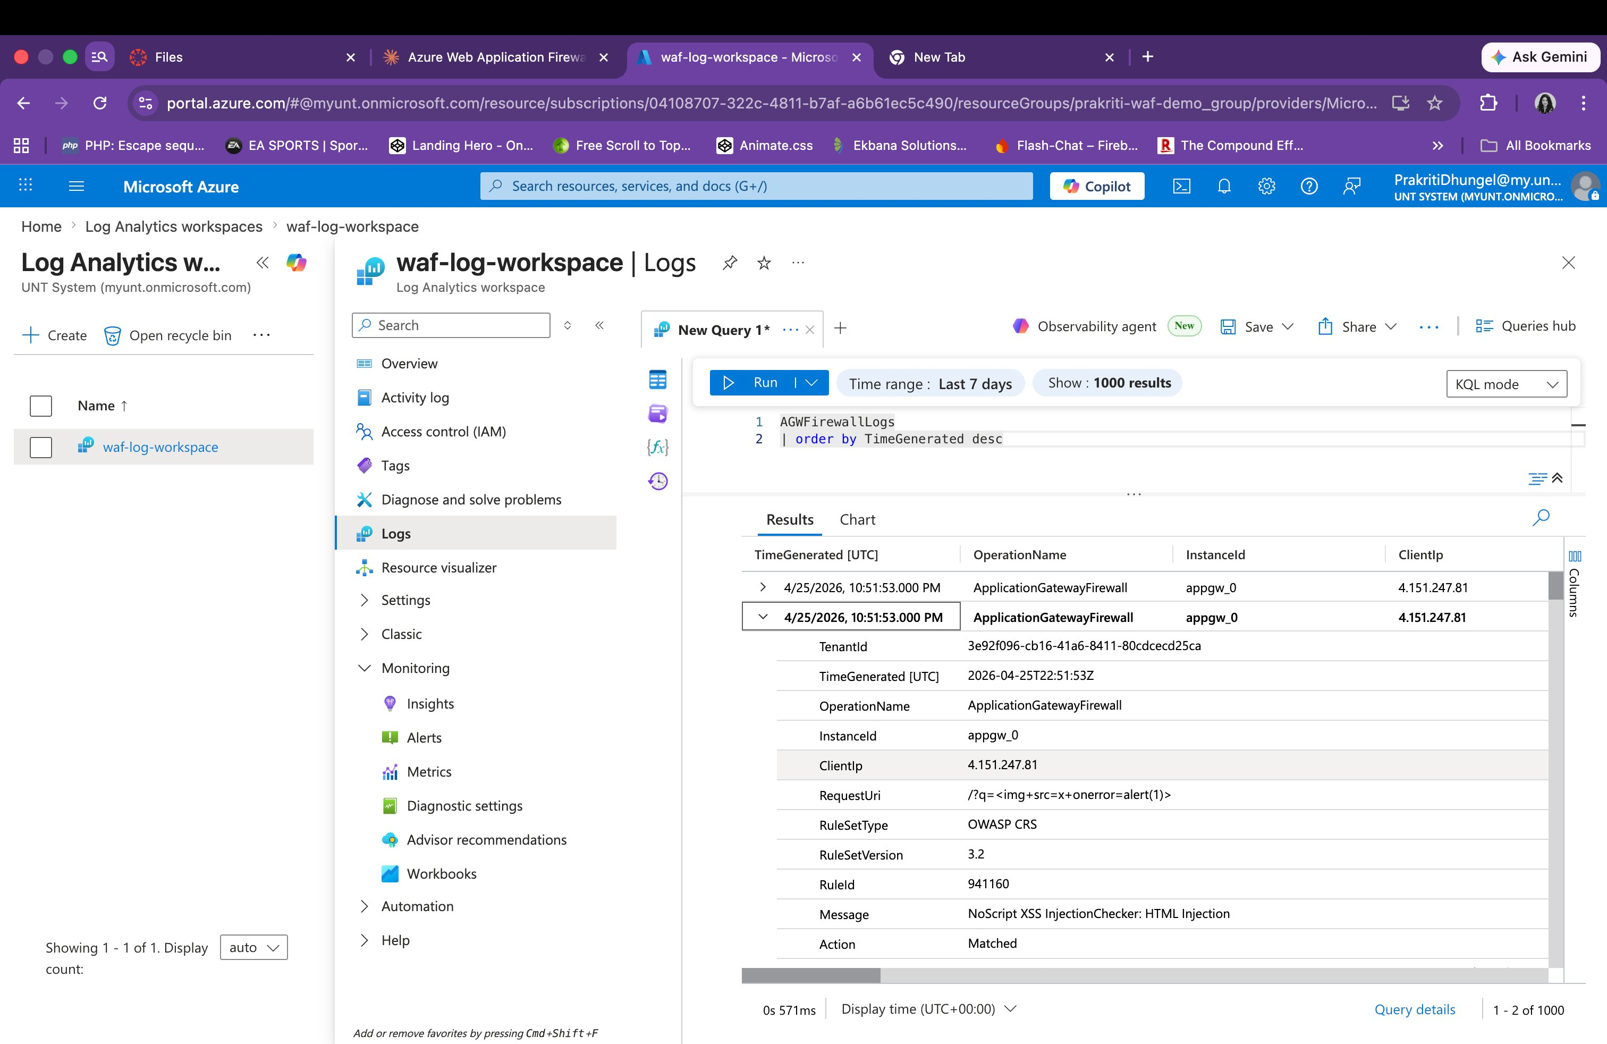
Figure 16: AGWFirewallLogs entry showing RuleId: 941160, Message: NoScript XSS InjectionChecker: HTML Injection — confirming multiple XSS rules triggered by the same payload

Log Entry 3 — XSS Attack: Rule 941120
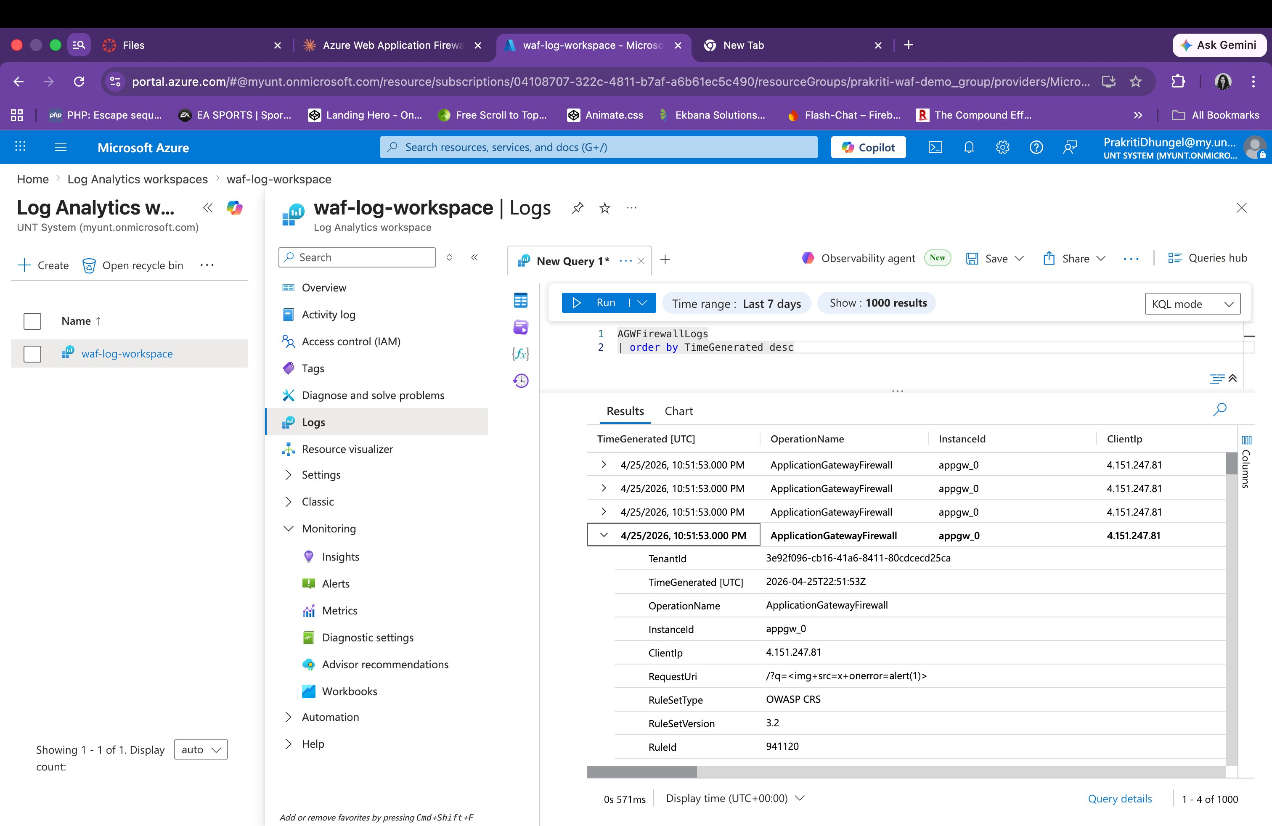
Figure 17: AGWFirewallLogs entry showing RuleId: 941120 triggered by the XSS payload — demonstrating layered XSS detection across multiple rule IDs

Log Entry 4 — Anomaly Score: Rule 949110 (Inbound Anomaly Score Exceeded)
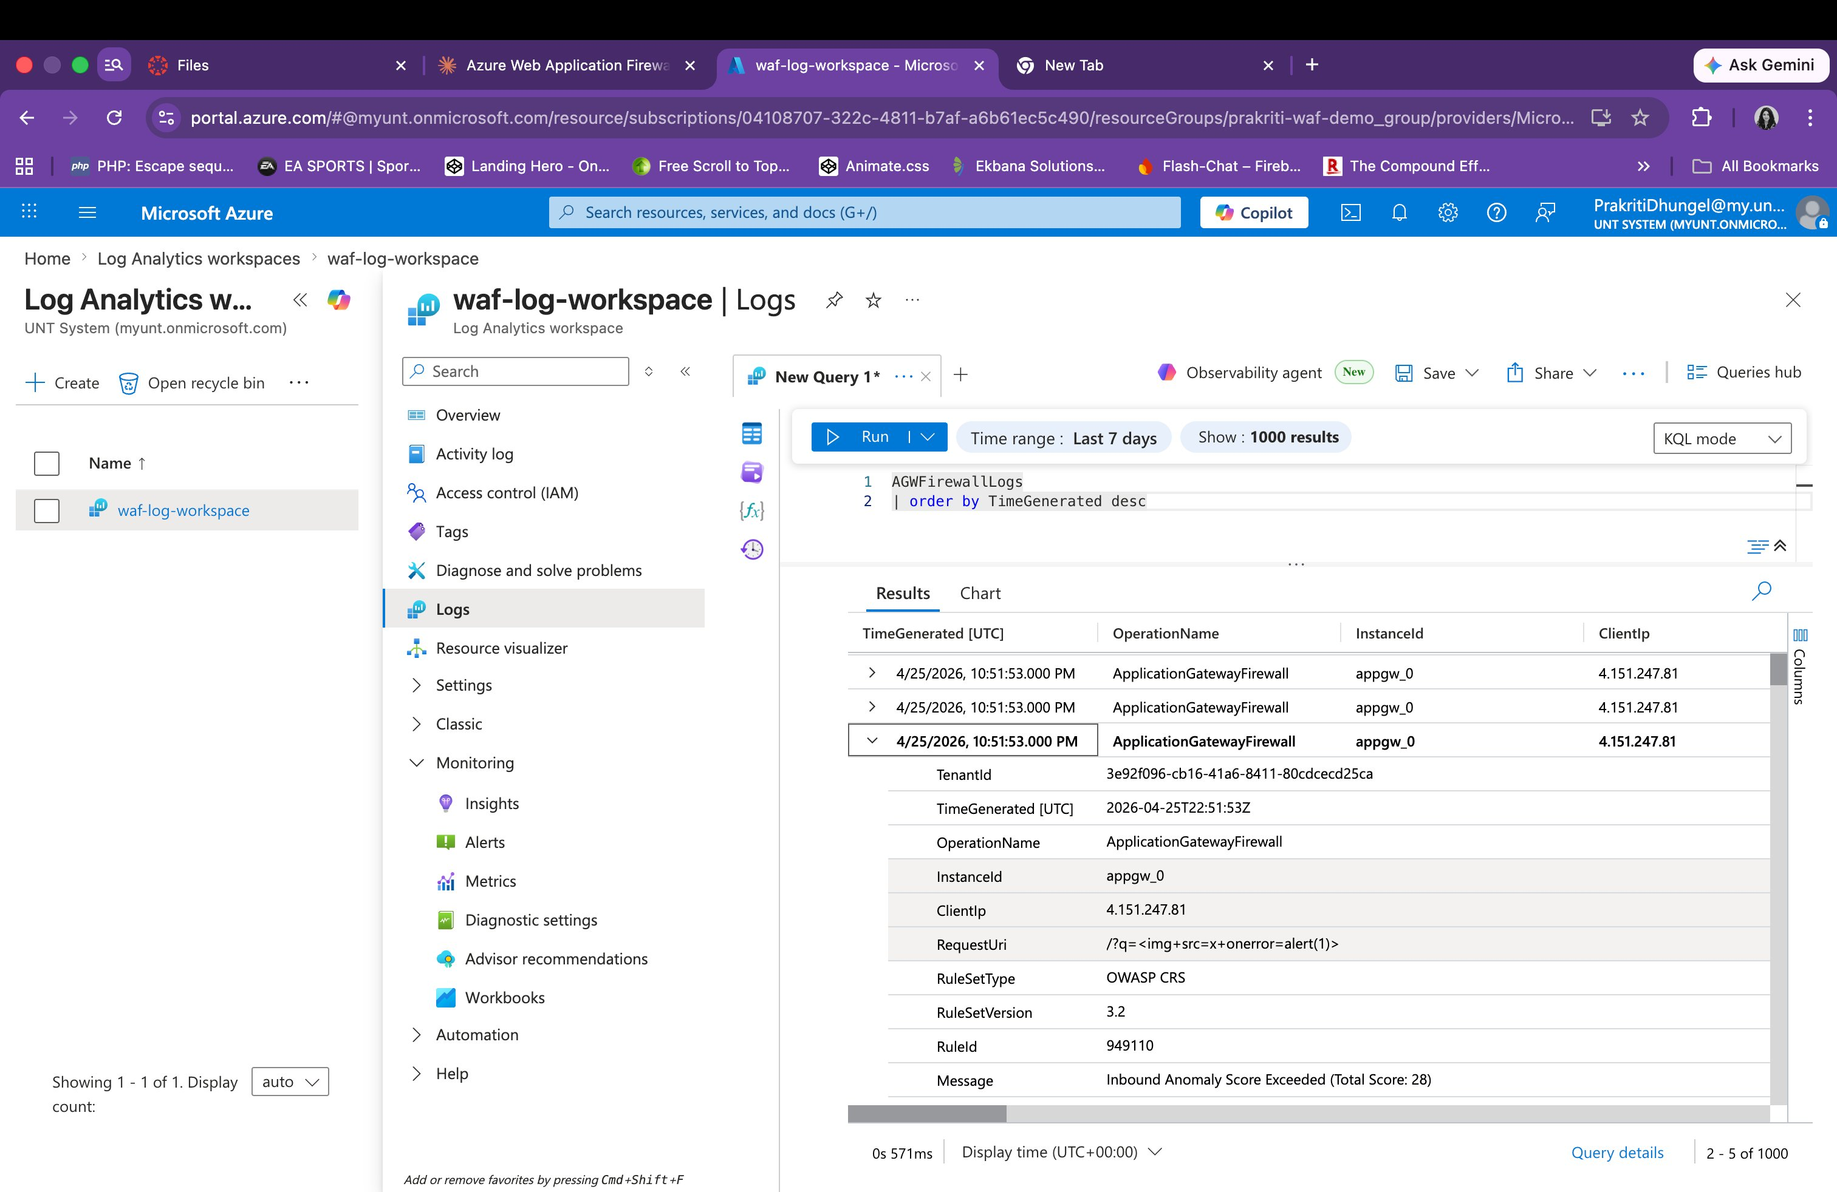
Figure 18: AGWFirewallLogs entry showing RuleId: 949110, Message: Inbound Anomaly Score Exceeded (Total Score: 28) — the WAF's anomaly scoring engine escalated the block based on cumulative rule matches

Log Entry 5 — Path Traversal: Rule 930120 (OS File Access Attempt)
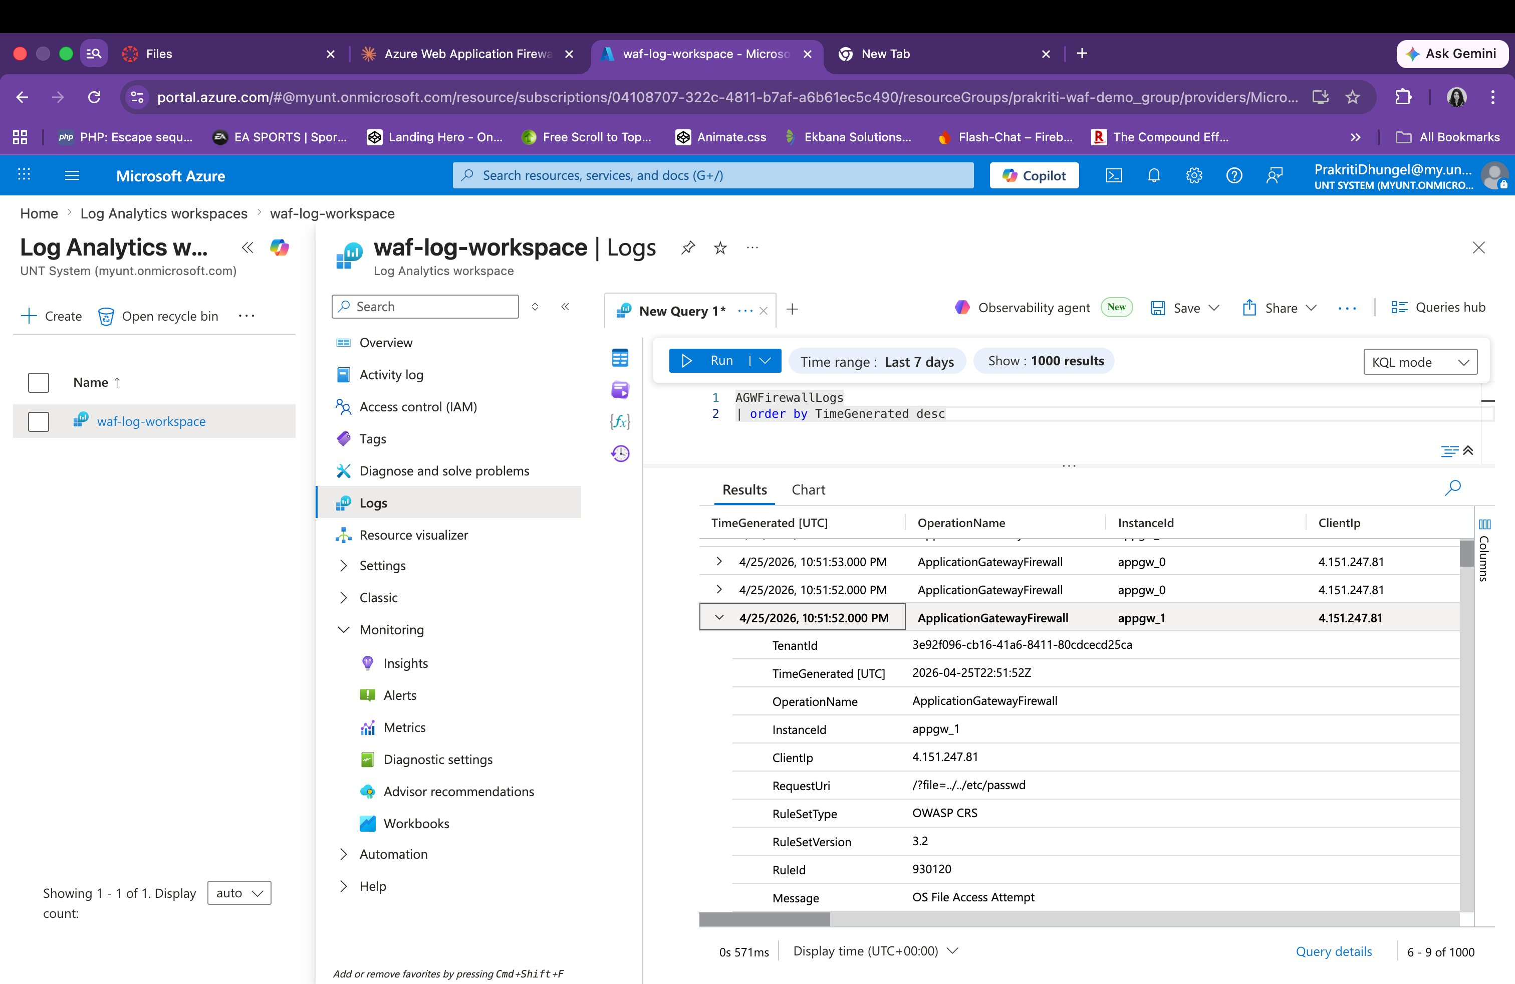
Figure 19: AGWFirewallLogs entry showing RequestUri: /?file=../../etc/passwd, RuleId: 930120, Message: OS File Access Attempt — path traversal attack detected and logged by OWASP Rule Group 930xxx

5.3 OWASP Rules Triggered Summary

Rule ID | Rule Group | Message | Attack Type | Action
941150 | 941xxx XSS Filter | XSS Filter - Category 5: Disallowed HTML Attributes | XSS (img onerror) | Matched/Blocked
941160 | 941xxx XSS Filter | NoScript XSS InjectionChecker: HTML Injection | XSS (img onerror) | Matched/Blocked
941120 | 941xxx XSS Filter | XSS via event handler | XSS (img onerror) | Matched/Blocked
949110 | 949xxx Anomaly | Inbound Anomaly Score Exceeded (Score: 28) | Multiple attacks | Blocked
930120 | 930xxx LFI | OS File Access Attempt | Path Traversal | Matched/Blocked

6. WAF Effectiveness Analysis

6.1 Complete Test Results

Test | Attack Type | Payload | Terminal Result | Cloud Shell Result | OWASP Rule
T1 | Baseline | GET / | 301 Redirect | 301 Redirect | N/A — Allowed
T2 | XSS Script Tag | <script>alert(xss)</script> | 403 Forbidden | 403 Forbidden | 941xxx XSS
T3 | XSS IMG Tag | <img src=x onerror=alert(1)> | 403 Forbidden | 403 Forbidden | 941150/941160
T4 | SQL Injection | ?id=1 OR 1=1 | URL Rejected | 403 Forbidden | 942xxx SQLi
T5 | Path Traversal | ../../etc/passwd | 301 Redirect | 403 Forbidden | 930120 LFI
T6 | Scanner Sim. | User-Agent: sqlmap/1.0 | 403 Forbidden | 403 Forbidden | 913xxx Scanner

6.2 Effectiveness Assessment

Attack Category | Detection Rate | Effectiveness | Evidence
XSS (Script Tag) | 100% | High | 403 from both terminal and Cloud Shell
XSS (IMG Tag) | 100% | High | Rules 941150, 941160, 941120 all triggered
SQL Injection | 100% | High | 403 from Cloud Shell; URL-rejected from terminal
Path Traversal | 100% | High | Rule 930120 confirmed in logs; 403 from Cloud Shell
Scanner Detection | 100% | High | SQLmap UA blocked instantly from both environments
Anomaly Scoring | 100% | High | Rule 949110 — Total Score 28 exceeded threshold

6.3 Key Observations
- The WAF successfully blocked all tested attack categories from both external (macOS terminal) and cloud-internal (Azure Cloud Shell) network perspectives, confirming enforcement at the Application Gateway layer.
- Multiple OWASP rules fired for a single attack payload (e.g., 941150, 941160, 941120 all triggered for the img XSS payload), demonstrating the defense-in-depth approach of OWASP CRS 3.2.
- The anomaly scoring engine (Rule 949110) escalated blocks based on cumulative score (28 points), which provides protection even for novel attacks that may only partially match individual rules.
- Path traversal attacks that returned 301 from the macOS terminal were confirmed blocked with 403 from Cloud Shell and logged with Rule 930120, indicating the WAF does detect this attack class.
- Both testing tools (macOS curl v8.7.1 and Azure Cloud Shell curl v8.11.1) produced consistent WAF responses, validating the reliability of the enforcement mechanism.

7. Recommendations

7.1 Immediate Configuration Improvements
- Enable HTTPS Listener: Configure an SSL/TLS certificate on the Application Gateway and add a listener on port 443. This eliminates HTTP 301 redirects and enforces end-to-end encryption.
- Explicit Path Traversal Custom Rule: Although Rule 930120 detected path traversal in Cloud Shell tests, adding a custom WAF rule explicitly blocking ../ sequences ensures consistent 403 responses across all client types.
- Tune Anomaly Score Threshold: Review the current anomaly score threshold (currently triggering at 28) and consider lowering it for stricter enforcement, particularly for endpoints handling sensitive data.

7.2 Enhanced Security Measures
- Rate Limiting Rules: Add custom WAF rules to throttle requests from single IP addresses to protect against brute-force attacks and volumetric DDoS.
- Geo-filtering: Implement geographic-based custom rules to restrict access from high-risk regions if the application serves a defined user base.
- Bot Manager Rule Set: Enable the Azure WAF Bot Manager rule set for more sophisticated bot detection beyond User-Agent string matching (Rule 913xxx).
- Azure DDoS Protection Standard: Enable DDoS Protection on the virtual network for volumetric attack mitigation at the network layer, complementing WAF application-layer protection.

7.3 Monitoring & Response
- Azure Monitor Alerts: Configure real-time alert rules on WAF block events (particularly Rule 949110 anomaly scores) to trigger automated incident response workflows.
- Log Analytics Dashboard: Build KQL-based dashboards visualizing attack trends, top blocked IPs, most-triggered rule IDs, and time-series attack frequency.
- Microsoft Sentinel Integration: Connect AGWFirewallLogs to Microsoft Sentinel for advanced SIEM correlation, threat hunting, and automated playbook responses.

8. Conclusion
This lab successfully demonstrated the end-to-end deployment and effectiveness of an Azure Application Gateway Web Application Firewall in protecting a web application against OWASP Top 10 attack categories. The configuration using OWASP CRS 3.2 in Prevention mode proved highly effective across all tested attack types.

A comprehensive testing approach was adopted using two environments — a local macOS terminal simulating external attackers and Azure Cloud Shell simulating cloud-internal threats. Both environments confirmed consistent WAF enforcement with HTTP 403 Forbidden responses for all attack payloads. Real WAF firewall logs retrieved from the AGWFirewallLogs table in Azure Log Analytics provided definitive proof of rule-level blocking, with specific OWASP rule IDs including 941150/941160 (XSS), 930120 (Path Traversal/OS File Access), and 949110 (Anomaly Score Exceeded) confirmed as active.

The lab reinforces the importance of cloud-native WAF solutions as scalable, low-maintenance security layers for web applications. Future enhancements including HTTPS enforcement, custom traversal blocking rules, rate limiting, anomaly score tuning, and SIEM integration would further strengthen the overall security posture of the deployment.

9. References
- Microsoft Azure. Application Gateway WAF Overview. https://learn.microsoft.com/en-us/azure/web-application-firewall/ag/ag-overview
- OWASP Foundation. OWASP Top Ten 2021. https://owasp.org/www-project-top-ten/
- Microsoft Azure. WAF CRS Rule Groups and Rules (OWASP 3.2). https://learn.microsoft.com/en-us/azure/web-application-firewall/ag/application-gateway-crs-rulegroups-rules
- Microsoft Azure. Diagnostic Logs for Application Gateway. https://learn.microsoft.com/en-us/azure/application-gateway/application-gateway-diagnostics
- Microsoft Azure. AGWFirewallLogs Table Reference. https://learn.microsoft.com/en-us/azure/azure-monitor/reference/tables/agwfirewalllogs
- OWASP. Web Security Testing Guide — Testing for XSS and SQL Injection. https://owasp.org/www-project-web-security-testing-guide/

